**2**

**REPRODUCTION**

**Chapter coverage**

2.1 *Introduction of reproduction*

2.2 *Reproduction in animals*

2.3 *Reproduction in plants*

**2.1 INTRODUCTION OF REPRODUCTION**

Organisms do not live for ever. Some tree are known to be thousands of years old; the oldest authenticated age lived by any mammal was 122 years 237 days by a human. Many insects live only for a few months: eventually all organisms die. Life on earth continuous because organisms reproduce before they die. The biological process by which organisms produce new individual of the same kind is called **reproduction**. It is one of the most fundamental characteristics of living organisms since each individual organism exists as the result of reproduction.

**Importance of reproduction**

The process of reproduction is very important to living organism due to the following reasons:

1. **It ensures the existence and perpetuation of species**

The fundamental importance of reproduction lies in the fact that it helps in the continuation of species in a population. Without a mechanism for reproduction, life would come to an end.

1. **It brings about variation in a population**

Reproduction especially sexual reproduction plays an important role in evolution by transmitting favourable variations from one generation to another through fertilization.

1. **It maintains the size of species in a population**

It maintains the size of species as the lost members of population are replaced by new ones.

**Types of reproduction**

There are two main types of reproduction namely:

* Asexual reproduction
* Sexual reproduction.

**Asexual reproduction**

Asexual reproduction is a type of reproduction which involves one parent only without the need for gamete formation and fusion (fertilization). The offspring produced here are genetically identical to their parents because there is no fertilization which could lead to variations. It mainly occurs in microorganisms like bacteria, protozoa, fungi as well as certain multicellular organisms like plants.

**Characteristics of asexual type of reproduction**

* Asexual reproduction involves only one parent hence the process does not require a mate for reproduction.
* Asexual reproduction involve mitosis hence produce offspring that are genetically identical to the parent.
* Asexual reproduction produces large number of offspring to ensure the survival chance.
* Asexual reproduction does not consume much time and energy since it does not involve gametogenesis or on seeking for a receptive mate.
* Asexual reproduction occurs in lower forms of organisms.

**Types of Asexual reproduction**

There are five major types of asexual reproduction include:

* Binary fission
* Budding
* Sporulation
* Fragmentation
* Vegetative propagation

1. **Binary fission**

Binary fission is a type of asexual reproduction by which a unicellular organism divides into two or more identical daughter cells. Bacteria and protoctists such as amoeba Figure 2.1 undergo this form of reproduction.

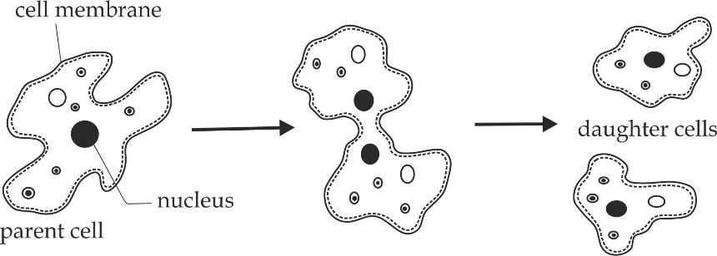

**Figure 2.1** binary fission in amoeba

1. **Budding**

Budding is a type of asexual reproduction whereby a new individual is produced from an outgrowth or *bud* from a parent. The bud grows and eventually breaks away from the parent. It then develops into a new individual, identical to the parent organism. Yeast Figure 2.2 and hydra undergo this form of asexual reproduction.

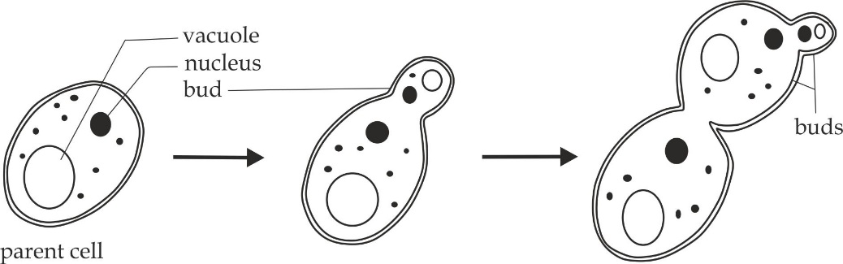

**Figure 2.2** budding in a yeast cell

1. **Sporulation**

Sporulation is a type of asexual reproduction whereby a new individual is produced from a spore. Sporulation occurs most commonly in fungi such as mucor or rhizopus as shown in Figure 2.3 and plants, whereby they are produced in structures called **sporangia**.

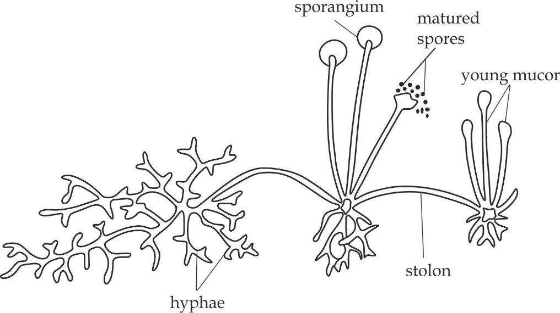

**Figure 2.3** sporulation from the mucor (rhizopus)

1. **Fragmentation**

Fragmentation is a type of asexual reproduction whereby an organism breaks into two or more parts, each of which grow and develop into a new individual organism. *Planarian* shown in Figure 2.4 and *spirogyr*a undergo this form of asexual type of reproduction.

1. **Vegetative propagation**

Vegetative propagation is a type of asexual reproduction whereby a relatively large and differentiated part of a plant become detached and develop into an independent plant. The new plant may normal be propagated from the stem, leaf, or root of the parent depending on the type of plant. In sugar cane and pineapples by **cutting** the stem, in mangoes, rubber, citrus and guava by **grafting** and in Jasmin plant by **layering.**

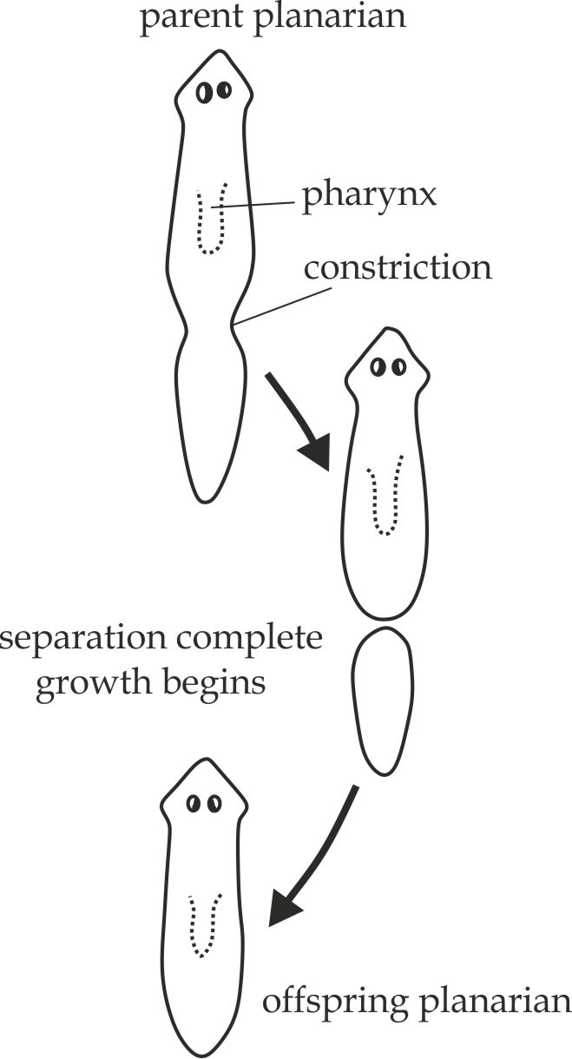

**Figure 2.4** fragmentation in the planarian

**SAQ 2.1**

**EZEB DAR 2010**

* Give one example in each case, list down five types of asexual reproduction.

**Advantages of asexual a reproduction**

1. It maintains genetic stability to the population since offspring produced are genetically identical to the parents.
2. It is a sure method of reproduction because it is independent of probable processes like fertilization, pollination and dispersal.
3. It produces large number of offspring in a short time to ensure survival chance in a population.
4. It saves energy and time that would be lost during gametogenesis or in search for mate.
5. It produces offspring that are able to survive in hash condition since they form cyst.
6. It produces offspring that are already adapted to their environment since they are genetically identical to their parents.

**Disadvantages of asexual reproduction**

1. It does not cause variations; this result in reduced hybrid vigour over a period of time.
2. It is easier to transmit hereditary diseases from parents to the offspring.
3. The offspring produced may not be able to adapt to the new change in the environment.
4. The production of too many offspring at a time may result in competition, overcrowding and exhaustion of resources.
5. The undesirable qualities in parents are retained in the offspring.
6. The parent sometimes disappear because its body no longer exists.

**Sexual reproduction**

Sexual reproduction is a type of reproduction which involves the production and fusion of female and male gamete to form a zygote which then grow into a new individual organism. The fusion of gametes is called **fertilization**. It occurs in higher animals and plants. Sexual reproduction must involve the process of nuclear division called **meiosis** in order to produce gametes.

**Interaction between meiosis and gametogenesis**

Meiosis and gametogenesis are always interlinked; because in the process of gamete formation, a nuclear division by meiosis process halves the normal chromosomes number, That is; gametes are **haploid**, and fertilization restores the **diploid** number of chromosomes. Without the reductive nuclear division in the process of sexual reproduction, the chromosome number would double in each generation.

**SAQ 2.2**

**SYNDICATE 2020**

* The process of meiosis and gametogenesis are always interlinked to each other. Explain.

**Characteristics of sexual reproduction**

* Sexual reproduction involves two different sexes (male and female sex) regardless whether they are found on one organism or on two different organisms. For this reason; the process is said to be biparental.
* Sexual reproduction involves meiosis hence produce offspring that are genetically different to the parents.
* Sexual reproduction consume much time and energy since it involves gametogenesis or on seeking for a receptive mate.
* Sexual reproduction produces less number of offspring in a population.
* Sexual reproduction occur in higher form of organisms such as mammals and plants.

**Advantages of sexual reproduction**

1. It increases the genetic variation in organisms of the same species due to genetic recombination during meiosis and the random fertilization. The result in increased hybrid vigour over a period of time.
2. It minimizes the rate of transmitting hereditary diseases from parents to offspring since it favours variation.
3. It produces less number of offspring which minimizes the exhaustion of resources and competition.
4. The undesirable qualities in parents are not retained in the offspring.
5. The offspring produced are able to adapt to the new change in habitat and environment condition.

**Disadvantages of sexual reproduction**

1. It does not maintain genetic stability to the population since offspring produced are genetically different to the parents.
2. It is not a sure method of reproduction because it is dependent on the probable processes like fertilization, pollination and dispersal.
3. It is a slow process and produce less number of offspring.
4. It produces offspring which are not well adapted to the environment.
5. It can lead to harmful mutation due to error in genetic recombination.

**Table 2.1 differences between asexual and sexual reproduction:**

|  |  |
| --- | --- |
| **Asexual reproduction** | **Sexual reproduction** |
| It does not involve the formation and fusion of gametes | It involves the formation and fusion of gametes |
| It involves only one parent | It involves two parents |
| It involves only mitosis | It involves meiosis and mitosis |
| Offspring are genetically identical to parents | Offspring are genetically different to parents |
| It is a rapid process which produce large number of offspring | It is a slow process which produce less number of offspring |
| It does not contribute to evolution | It contributes to evolution |
| It occurs in microscopic organisms | It occurs in macroscopic organisms |

**SAQ 2.3**

**NECTA 2004**

* Define the following terms:

1. Sexual reproduction
2. Asexual reproduction

* Distinguish between sexual and asexual reproduction

**2.2 REPRODUCTION IN ANIMALS**

We have already concerned with the introduction of reproduction in general as illustrated by a wide range of organisms. In this part we shall look at reproduction in animals with particular reference to human. In considering how animals reproduce; the following aspects need to be addressed:

* The concept of meiosis
* Gametogenesis in human
* Female reproductive cycles
* Capacitation
* Fertilization
* Embryonic development
* Extra embryonic membranes
* The placenta
* Hormonal changes during pregnancy
* Birth process and parental care
* Multiple births
* Metamorphosis

**2.2.1 THE CONCEPT OF MEIOSIS**

Meiosis is a type of nuclear division in which a diploid cell (2n) divides to produce four haploid cells (n).This process takes place during gametogenesis in reproductive organs of sexually reproducing organisms.

**Importance of meiosis in sexually reproducing organisms**

1. **It produces male and female gametes (sex cells**)*.*

It takes place inside the reproductive organs; testis in males to produce sperms and ovaries in female to produce egg cells.

1. **It maintains chromosomes number**

It ensures a constant diploid number of chromosomes when produced haploid number of chromosomes fuse during fertilization.

1. **It leads to genetic variation**

It provides opportunities for new combination of genes to occur in the gametes in two ways – independent assortment of chromosomes during meiosis I and crossing over between homologous chromosomes at the chiasmata during prophase I.

**SAQ 2.4**

**ST JOSEPH AND TAMBAZA JOINT 2020**

* Explain the meaning of meiosis and its significance in sexually reproducing organisms.

**The stages of meiosis**

The process of meiosis consists of two successive nuclear divisions, namely; meiosis I and meiosis II.Both stages are preceded by a non – dividing phase called interphase.

**Meiosis I**

This is the first stage of the two consecutive meiotic nuclear division. Its principal role is to reduce the number of homologous chromosomes to half before meiosis II.The mechanism of meiosis I involves four phases, namely; prophase I, metaphase I, anaphase I and telophase I.

1. **Prophase I**

This is the longest phase of meiosis I because it is divided into five sub consecutive phases that are leptotene, zygotene, pachytene, diplotene and diakinesis.

In **leptotene** sub phase, chromosomes become shorten, thick and visible as indicated in Figure 2.5.

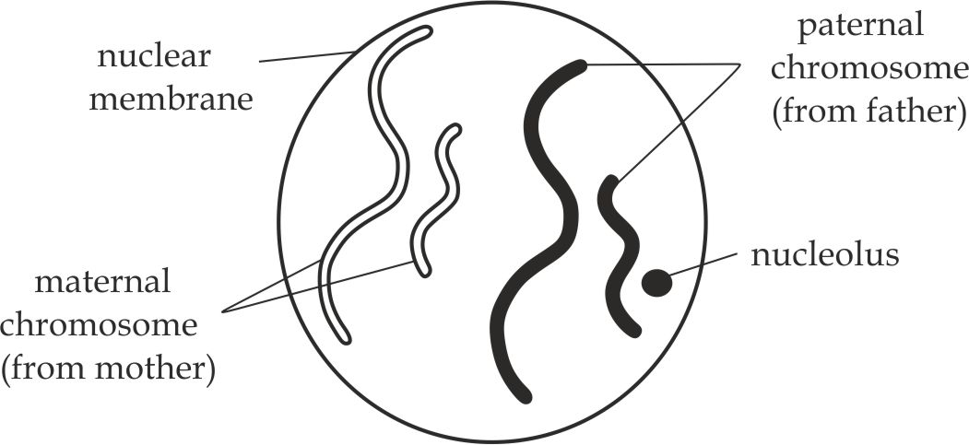

**Figure 2.5** Leptotene stage

In **zygotene** sub phase, the paternal (father) and maternal (mother) homologous chromosomes pair up side by side by the synaptic force of attraction to form a bivalent, a process is called synapsis as indicated in Figure 2.6.

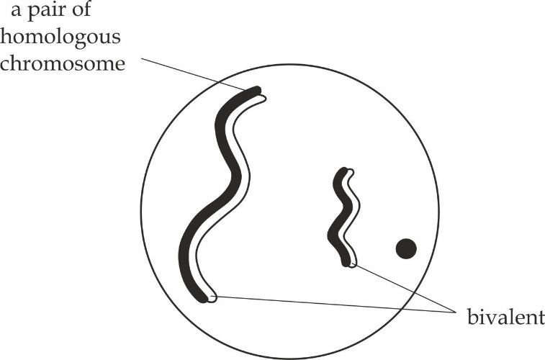

**Figure 2.6** Zygotene stage

In **pachytene** sub phase, homologous chromosome repel to each other and separate partially except at one point of attachment is known as **chiasma** (plural; chiasmata).It is the site for exchange of genetic materials between the chromatids of homologous chromosomes, It is therefore brings about genetic variation hence evolution; This process is referred to as **crossing over**. It also hold the homologous chromosomes together while they move to the spindle fibre during metaphase.

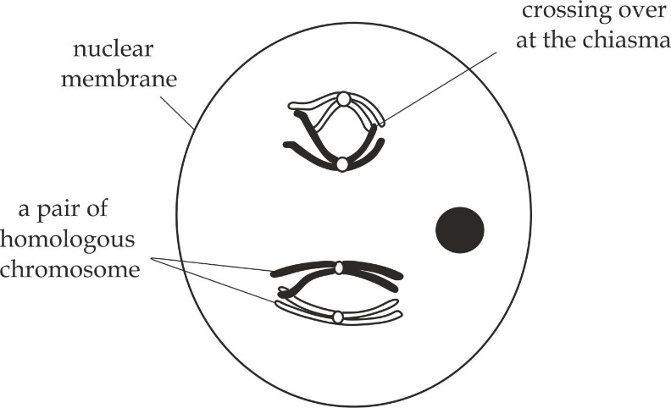

**Figure 2.7** Pachytene stage

In **diplotene** sub phase, the paired chromosome disintegrate and sister chromatids repel to each other as indicated in Figure 2.8.

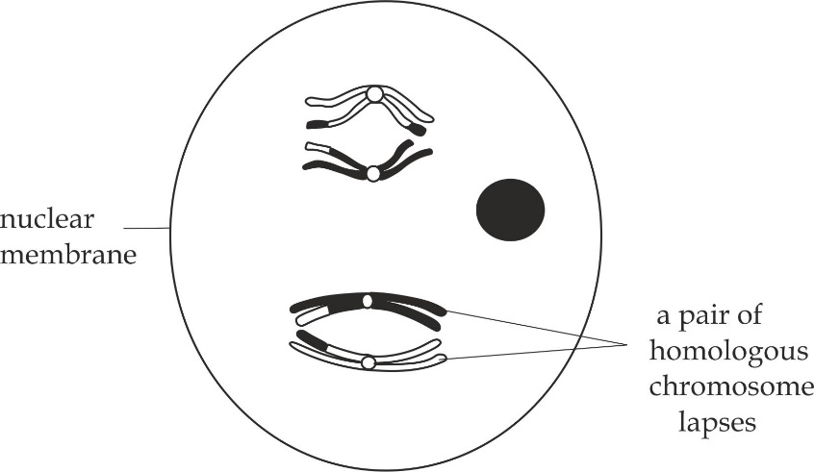

**Figure 2.8** Diplotene stage

In **diakinesis** sub phase, the centrioles migrate to the opposite poles, the spindle fibres start to develop and nucleolus and nuclear membrane start to disintegrate as indicated in Figure 2.9.

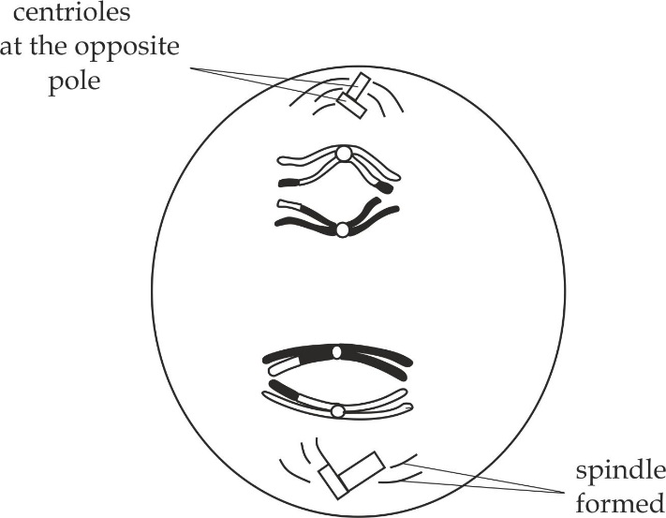

**Figure 2.9** Diakinesis stage

**SAQ 2.5**

**NECTA 2016**

* Describe the events of prophase I of meiosis I.

1. **Metaphase I**

It is characterized by the following main events:

* Pairs of homologous chromosomes align at the equator and form the double rows.
* The nuclear membrane and nucleolus disappear completely.
* The spindle fibres are formed and attach homologous chromosomes at the centromere as indicated in Figure 2.10.

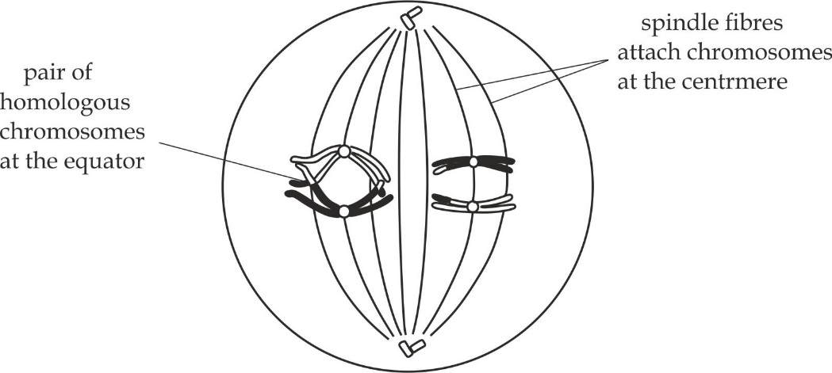

**Figure 2.10** Metaphase I

1. **Anaphase I**

This is a short and rapid phase in which spindle fibres shorten and pull the homologous chromosomes toward the opposite poles (*the centromeres do not divide*) as indicated in Figure 2.11.

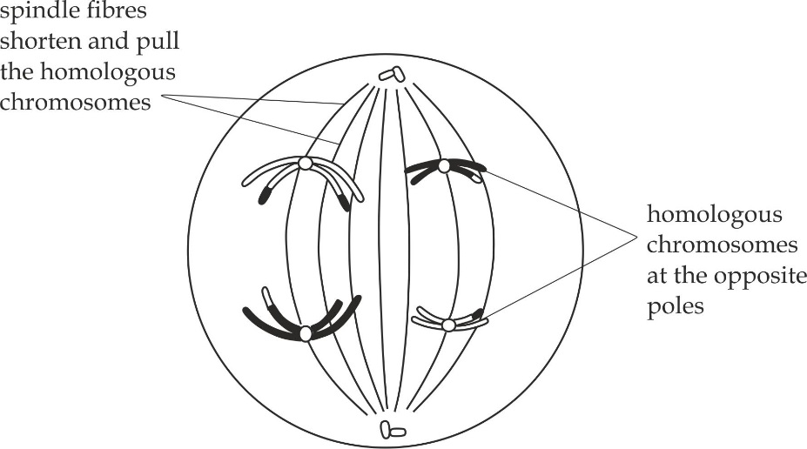

**Figure 2.11** Anaphase I

1. **Telophase I**

It is characterized by the following main events:

* The homologous chromosomes arrive at the opposite poles and the chromosomes condense.
* The spindle fibres disappear.
* The nuclear membrane and nucleolus reappear in each group of homologous chromosomes.
* Cytokinesis begins which form two separate haploid daughter cells, in animal cells, it involves the formation of cleavage furrow by folding of the plasma membrane inward as indicated in Figure 2.12. In plants, cytokinesis is accomplished by the cell plate formed at the equator of the old cell that will soon be two separate cells.

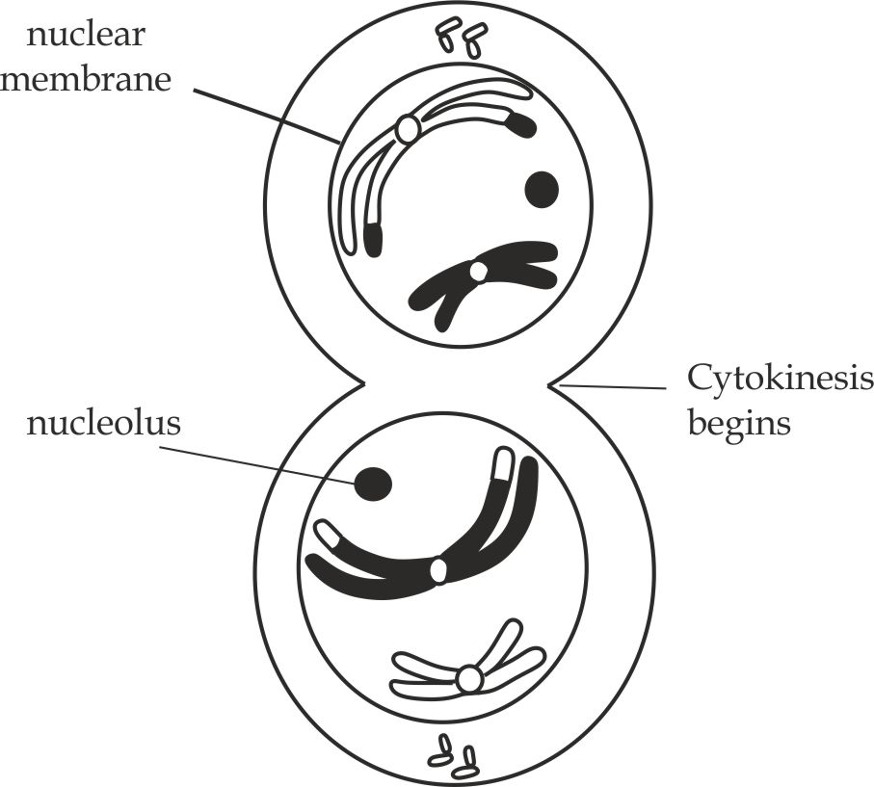

**Figure 2.12** Telophase I

**Meiosis II**

This is the second stage of the meiotic nuclear division. Cells move from meiosis I to meiosis II without replicating their DNA.Meiosis II is a shorter and simpler process than meiosis I. Its principal role is to separate the sister chromatids .It is similar to mitosis because the formed daughter cells have the same number of chromosomes (chromatids) as the parent cells. The produced daughter cells are haploid (have one chromosome from each homologous pair), but their chromosomes still consist of two sister chromatids. These sister chromatids tend to separate, producing four (4) haploid cells whose chromosome have just one chromatid each.

The mechanism of meiosis II involves four main phases, namely; prophase II, metaphase II, anaphase II and telophase II.

1. **Prophase II**

It is first stage of meiosis II which is characterized by the following main events as indicated in Figure 2.13:

* The chromosomes become shorten, thicken and clearly visible as double chromatids held together by a centromere.
* In animal cells, the centrioles begin to move to the opposite poles of the cell and form the star shaped microtubule structures called asters, some of these microtubules called spindle fibres, may be seen extending across the cell from one pole to another. In plant cells, there are no asters.
* At the end of prophase, nucleolus and nuclear membrane (envelope) disintegrate.

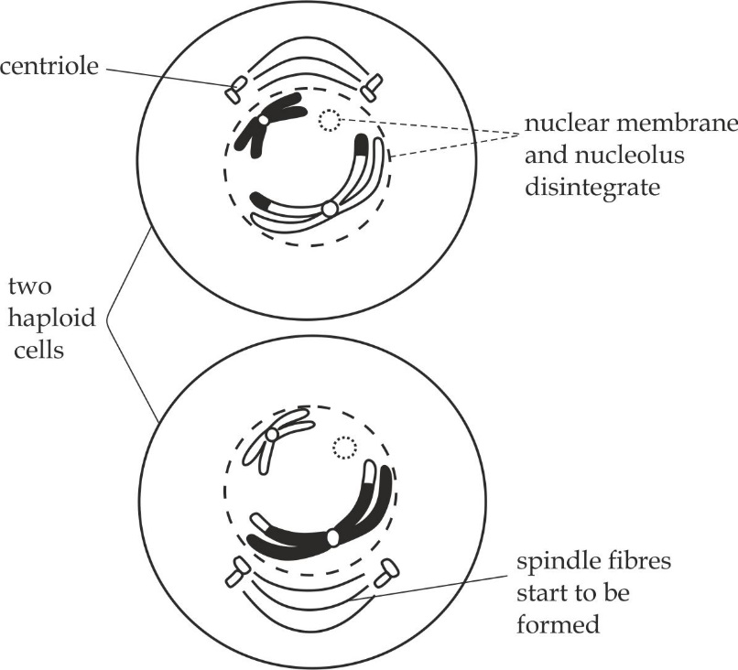

**Figure 2.13** prophase II

1. **Metaphase II**

Metaphase is a second stage of meiosis II which is characterized by the following events as shown in Figure 2.14.

* The chromosomes align at the equator of the spindle fibres form a single raw.
* The nucleolus and nuclear membrane disappear completely.
* The spindle fibres are complete formed in each daughter cell and attach chromosomes at the centromere.

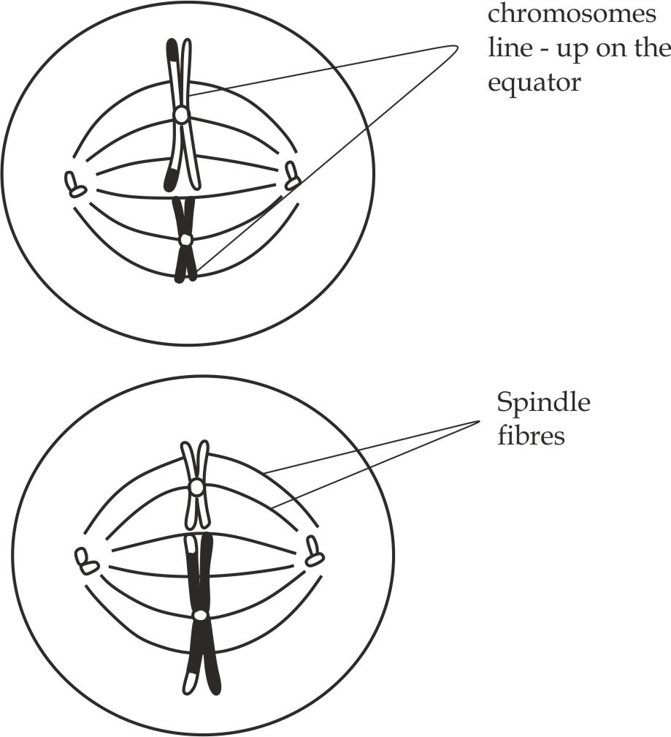

**Figure 2.14** Metaphase II

1. **Anaphase II**

Anaphase is the third phase of meiosis II whereby the spindle fibres pull the chromatids to the opposite poles with the centromere being pulled first as indicated in Figure 2.15.

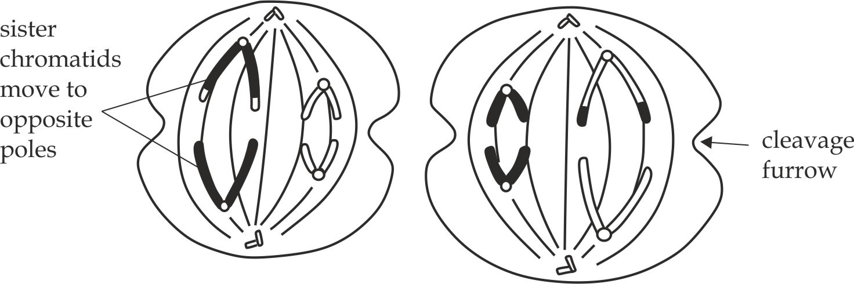

**Figure 2.15** Anaphase II

1. **Telophase II**

This is the last phase of meiosis II which is characterized by the following main events as indicated in Figure 2.16.

* The chromatids reach their destination in the opposite poles of their destination in the opposite poles of the spindle. The chromosomes become very distinct as they lengthen and uncoil.
* The spindle fibres disappear and centrioles replicate.
* The nuclear membranes and nucleolus reappear around each group of chromosomes.
* The cytokinesis or cleavage of the cell begins to give four haploid daughter cells. These are collectively known as tetrad. In a human being, the number of chromosomes in the parent cell is 46. Thus, after meiosis during gametogenesis, the number of chromosomes in each of the four haploid daughter cell will be 23.

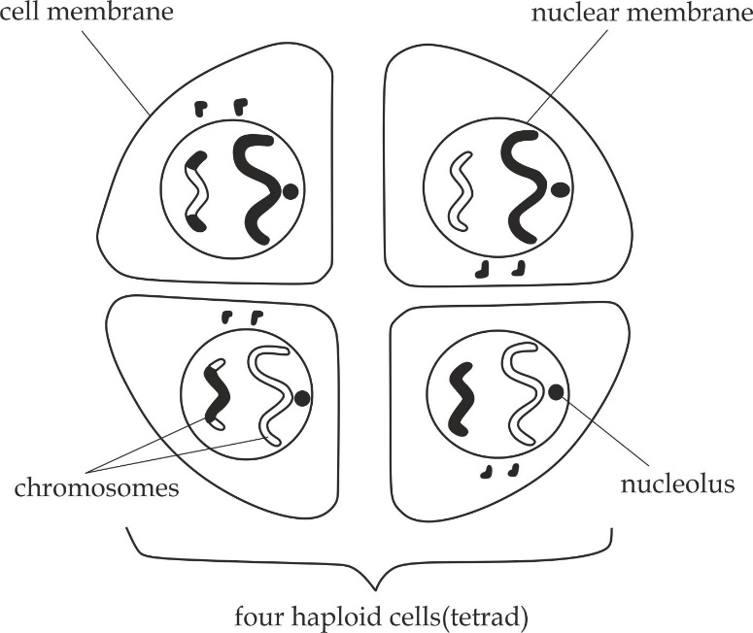

**Figure 2.16** Telophase II

Key point

In a human being, the chromosomes in the parent cell is 46.Thus, after meiosis during gametogenesis, the number of chromosomes in each of the four haploid daughter cells will be 23.

**Similarities between mitosis and meiosis**

1. Both are process of nuclear division.
2. Both process pass through four stages, namely; prophase, metaphase, anaphase and telophase.
3. Both are preceded by interphase; during which DNA replication occurs.
4. Both involve diploid parental cell.
5. Both involve movement and rearrangement of chromosomes.
6. Both occur in living cells; that is plant cells and animal cells.

**Table 2.2 Differences between mitosis and meiosis:**

|  |  |  |
| --- | --- | --- |
| **Event** | **Mitosis** | **Meiosis** |
| **Site of occurrence** | It occurs in body cells | It occurs in germ cells |
| **Cycles of division** | It involves one cycle | It involves two cycles |
| **Daughter cells** | Daughter cells are usual identical to parental cell | Daughter cells are not similar from the parental cell |
| **Prophase** | There is no chiasmata or crossing over | In prophase I, there is chiasmata formation and crossing over |
| **Metaphase** | Pair of chromatids form a single *(one)* row on the equator of the spindle | Pair of chromosomes form a double *(two)* row on the equator of the spindle in metaphase I |
| **Anaphase** | It involves separation of *sister chromatids* | It involves separation of *homologous chromosomes*, in anaphase I |
| **Telophase** | Two daughter cells are produced with the same number of *chromosomes* as the parental cell | Four daughter cells are produced with half total number of *chromosomes* as the parental cell |

**SAQ 2.6**

**KILIMANJARO 2020**

* Based on the following stages of cell division, differentiate with illustration between mitosis and meiosis:

1. Prophase
2. Metaphase
3. Anaphase
4. Telophase

* Write four similarities between meiosis and mitosis.

**2.2.2 GAMETOGENESIS IN ANIMALS**

Gametogenesis is the process of gamete formation in both males and females reproducing sexually. In animals, it occurs in germinal layer of the gonads. In males, it occurs in testes while in females occur in ovaries.

**Types of gametogenesis**

The process of gamete formation in animals is divided into two types**,** which are spermatogenesis in males and oogenesis in females.

**Spermatogenesis**

Spermatogenesis is the production of haploid gametes (sperms) in testes. The process of spermatogenesis involves three phases: multiplication, growth and maturation phase.

1. **Multiplication phase**

This is the first phase whereby the diploid germinal epithelial cells or primordial germ cells in the outer layer of seminiferous tubule undergo repeated mitotic division to produce diploid cells called spermatogonia (singular – spermatogonium).

1. **Growth phase**

This is the second phase; during the growth phase, each spermatogonium increase in size and develops into primary spermatocytes; the primary spermatocytes undergo meiosis I to produce secondary spermatocytes, which in turn divide by meiosis II, to produce spermatids.

1. **Maturation phase**

The spermatids are immature male gametes, which are finally converted into mature spermatozoa or sperms in a process called **spermatogenesis** as shown in Figure 2.17. The sertoli cells are responsible for remoulding spermatids to develop tails and mature into sperms. These cells are important in nourishing the developing spermatozoa by providing it with oxygen, nutrients and exchange of metabolic wastes. This is done by blood vessel going through sertoli cells.

**Key point**

Sperms production is very sensitive to heat. If they get too hot, the cells in the tubules will not develop into sperms. This is why the testes in man are located outside the body cavity.

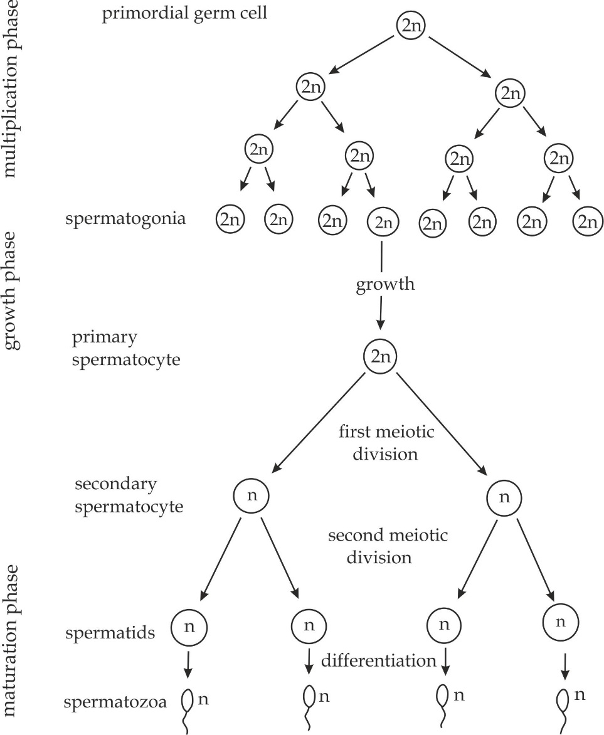

**Figure 2.17** The mechanism of spermatogenesis in human

**Microscopic structure of the testis**

Each testis is an ovoid structure about 5cm long, its 300 lobules each contain up to four highly coiled, sperm – producing **seminiferous tubules** which are lined by germinal epithelial cells as indicated in Figure 2.18,which divide repeatedly, forming cells called spermatogonia. Some of these spermatogonia divide by mitosis to produce more spermatogonia, others produce sperms. Between the sperm – producing cells are large **sertoli cells** which nourish the spermatids as they mature into spermatozoa around these are **interstitial cells**, which produce androgen. Sperm production begins at puberty and a healthy adult male produce hundred million sperm each day and continuous throught.

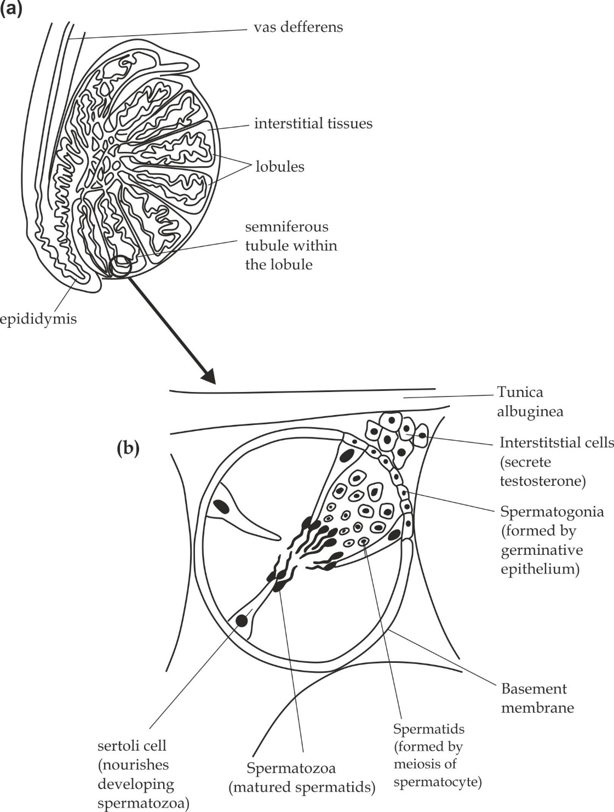

**Figure 2.18** (a) LS of testis;

**Figure 2.18** (b) TS of seminiferous tubule

**SAQ 2.7**

**NECTA 2003**

* Figure 2 below represent a cross section of a seminiferous tubule, Study the figure and answer the questions below it.

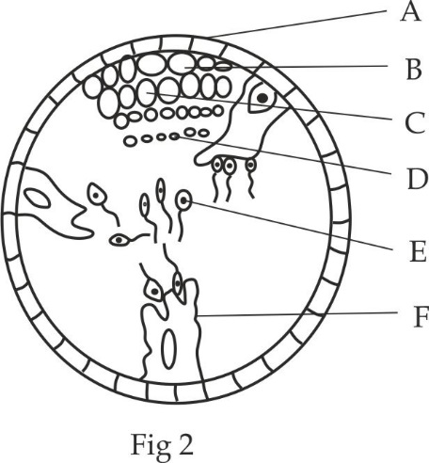

1. Name the parts labelled A – F.
2. Which structure forms the part labelled B?
3. Which process is involved in the transformation of structure C to D?
4. Explain the function of the structure labelled F.

**Hormonal regulation of spermatogenesis**

Spermatogenesis is usual controlled by both the hypothalamus and anterior pituitary gland working together. The hypothalamus secretes **gonadotropin – releasing hormone (GnRH)** which travels in small veins to the pituitary gland. This hormone stimulates the anterior pituitary gland to secrete two hormones called **gonadotrophins** that stimulates gonads. In this case, the testes.The gonadotrophins hormones are **follicle stimulating hormone (FSH)** and **lutenizing hormone (LH**). FSH stimulates spermatogenesis and sertoli cells to mould and nourish spermatids to produce spermatozoa as shown in Figure 2.19.LH is an interstitial cell – stimulating hormone (ICSH), hence it stimulates the synthesis of testosterone by interstitial cells (Leyding cells) of the testis. Testosterone is largely responsible for initiating and maintaining the **secondary sexual characteristics** of the male. These include the growth of the sex organs, the growth of body hair (facial and pubic), deep voice and general muscular development. When the rate of spermatogenesis is high, **inhibin** (a glycoprotein hormone) is released which reduce the secretion of follicle stimulating hormone (FSH) from anterior pituitary gland by negative feedback control mechanism. On the other hand when the level of testosterone is high result into a decrease in secretion of lutenizing hormone (LH) from the anterior pituitary gland.

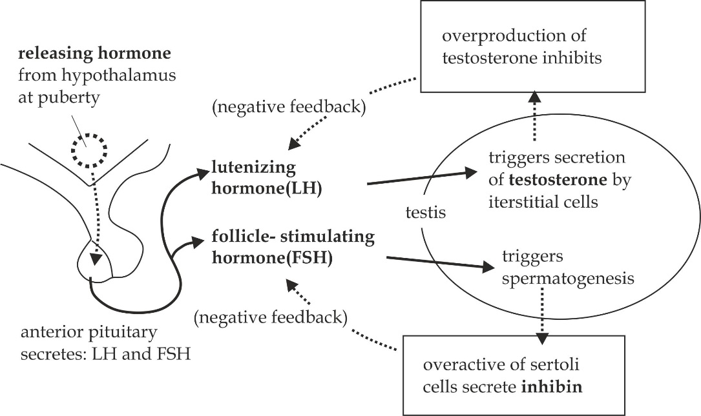

**Figure 2.19** Hormonal regulation of spermatogenesis

**SAQ 2.8**

**FOSCE 2022**

* Explain the hormonal control of spermatogenesis.

**Structure of a spermatozoan**

Structurally, a mature spermatozoan has four distinctive regions, namely; head, neck, middle piece and tail.

1. **Head**

It contains haploid nucleus which carriers the hereditary materials from the paternal and acrosome which carrier’s powerful hydrolytic enzymes *(protease and hyaluronidase)* which are responsible for digesting outer egg cell wall during fertilization.

1. **Neck**

It has a short region which contains centrioles microtubules that develops axial filaments of the sperm tail.

1. **Middle piece**

It has numerous mitochondria necessary to provide energy needed to propel the spermatozoa towards the human egg cell (ovum) in the female reproductive system.

1. **Tail**

It contains flagella which aid movement to the spermatozoa toward the human egg cell in the female reproductive system.

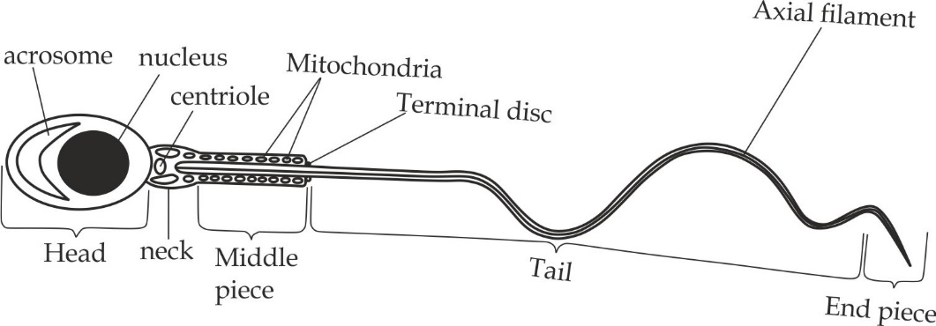

**Figure 2.2**0. Structure of a mature spermatozoan (sperm)

**Adaptations of spermatozoan**

The adaptation of the spermatozoan to its functions include the following:

1. **Presence of acrosome**

It contains hydrolytic enzymes such as protease and hyaluronidase to digest outer egg cell wall during fertilization.

1. **Presence of nucleus**

It transmits genetic materials (DNA) from the father to the offspring.

1. **Presence of centrioles**

They aid in the formation of axial filament of the flagellum.

1. **Presence of numerous mitochondria**

They produce energy needed for propelling the spermatozoa toward the egg cell in the female reproductive tract.

1. **Presence of tail**

They contain flagellum which propel the sperm towards the egg cell in the female reproductive tract.

**SAQ 2.9**

**FEZA BOYS 2007**

* Draw a well labelled diagram of human sperm cell which is mature and show how is related to its functions.

**Oogenesis**

Oogenesis is the production of haploid gametes (egg cells or ova) in ovaries. Like spermatogenesis, the oogenesis involves three phases: multiplication, growth and maturation phase as shown in Figure 2.21.

1. **Multiplication phase**

Multiplication as the initial phase of oogenesis starts during embryonic or foetal development (before birth).During this first phase, the diploid primordial germ cells undergo repeated mitotic divisions to produce many oogonia (singular – oogonium).

1. **Growth phase**

In growth phase, each oogonium, grows and develops into a primary oocyte due to accumulation of nutrients. The primary oocyte remains at prophase I throught the childhood. The onset of puberty causes continued development of the arrested primary oocytes, to secondary oocytes during female’s fertile years. Thus, every month, one primary oocyte complete meiosis I to produce two haploid cells. One of the two cells receives a large proportion of cytoplasm and become a functional secondary oocyte. The second cell receives a very small proportion of cytoplasm and become a non-functional unit called the first polar body. The secondary oocyte starts meiosis II which stops at metaphase II. The changes in the released secondary oocyte depend on whether the oocyte is fertilized with spermatozoan or not. Thus, if it does not unite with the male gamete, the process does not go beyond this stage, However, if it meets the male gamete, the secondary oocyte become stimulated to complete meiosis II that produce a functional ootid and a second non – functional polar body.

1. **Maturation phase**

In maturation, the ootid is transformed into an ovum and polar bodies degenerate.

**Key points**

* The production of egg cells begins in the ovaries of the foetus before birth, but the final development of the individual egg is completed only in adult life, anything from 11 – 55 years later.
* At birth the two ovaries each contain up to 200 000 primary oocytes, each become surrounded by a layer of follicle cells forming a structure known as a primary follicle.

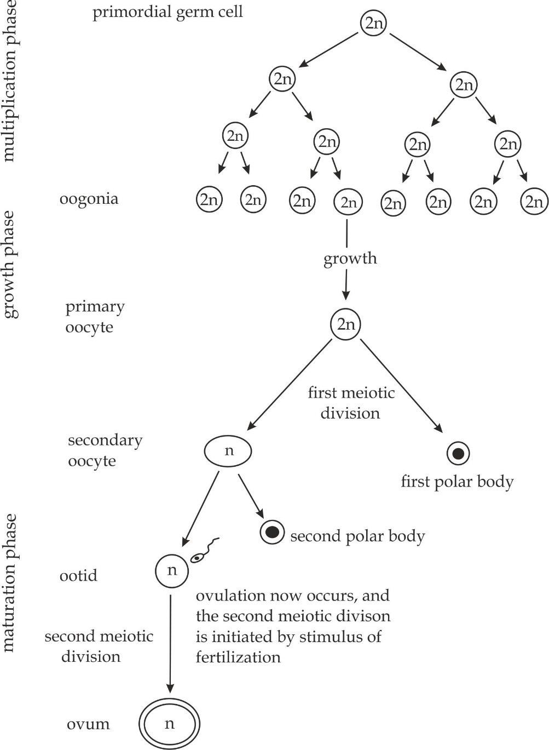

**Figure 2.21** The mechanism of oogenesis in human

**SAQ 2.10**

**LAKE ZONE MOCK 2013**

* Draw a well labelled diagram of human egg cell
* By using a well labelled diagram; describe the mechanism of oogenesis in human.

**Microscopic structure of the ovary**

In contrast to the testis, which is made up of numerous tubules, the ovary is an ovoid solid structure of about 3cm long.It is largely made up of connective tissue around which is a protective capsule. The inner composition of ovary depends on the stage of development which are explained as follows;

* During **fetal development** cells of the germinal epithelium beneath the protective capsule undergo repeated mitotic division, and large number of **oogonia** are formed. Oogonia migrate into the connective tissues of the ovary, and there grow and enlarge to form **primary oocytes.** So that, by the third month of fetal development, no oogonia are left.
* **At birth**, each ovary contains up to 200 000 primary oocytes, each surrounded by a large of follicle cells, forming a structure known as a **primary follicle**, which remain dormant until puberty, less than 1% of follicles will complete their development, the rest will cease and degenerate, and never produce eggs at all.
* After puberty (*from the age of about 11 upward*), hormones are released by the pituitary gland stimulates the further development of some of these follicles, each month, the primary oocyte completes the first division of meiosis to become a **secondary oocyte** and a smaller polar body**.** At the same time, the smaller cells around the follicle multiply so that the follicle increase in size from less than 1mm to over 100 mm in diameter, fluid filled cavity called the **antrum** now form between the follicle cells .meanwhile, the connective tissues inside the ovary forms a protective sheath around the follicle called the **theca** and it has two layers; a vascular inner layer and a fibrous outer layer; the whole structure is now called a **Graafian follicle**, and follicle cells begin to produce oestrogen. The mature graffian follicle presses against the surface of the ovary.
* **At ovulation** it bursts through the ovary wall releasing not an egg cell but the secondary oocyte; the second meiotic division to produce an ovum only occurs if a sperm penetrates this secondary oocyte. Some follicle cells leave the ovary with the secondary oocyte as corona radiata into the fimbriae of the oviduct, most follicle cells remain inside the ovary, where they become large and glandular to form the **corpus luteum.** In the human female, ovulation occurs from one of the two ovaries about once every 28 days throught the reproductive period if pregnant will not occur.
* **At menaupose** *(at age 44 - 55 years)* monthly ovulation cease because primary follicles degenerate.

One complete series of stages in the development of primary follicle to corpus luteum is represented in Figure 2.22.This vertical section through an ovary represents the stages of development of a single follicle. Of the 400 000 primary follicles in the ovaries of an adolescent girl.

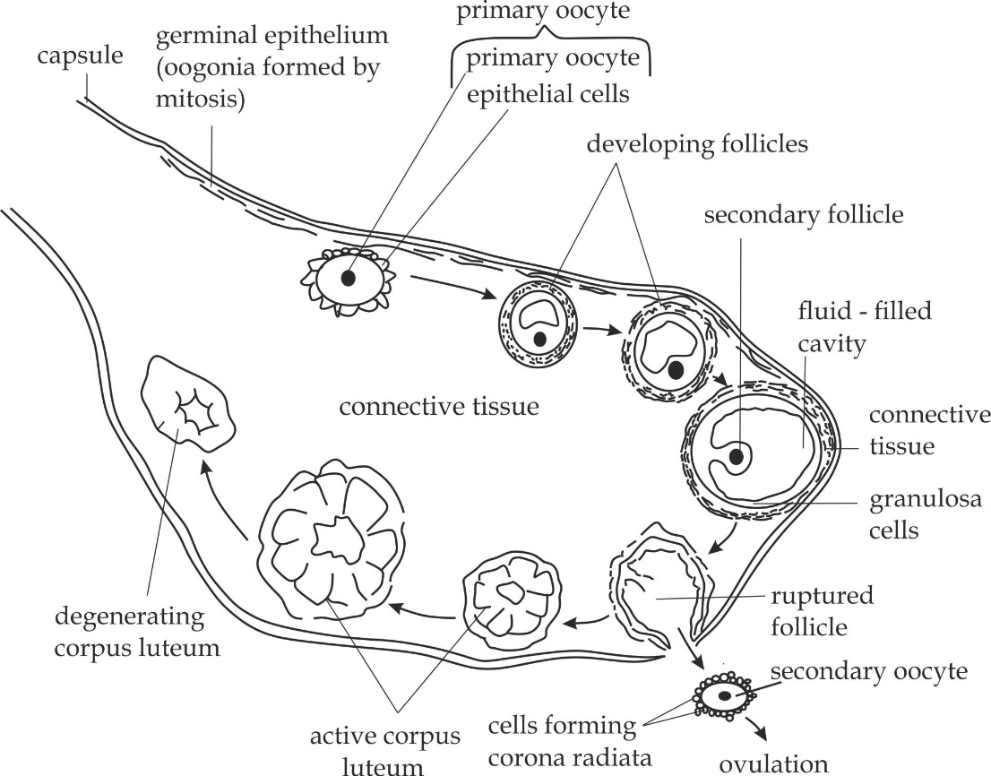

**Figure 2.22**  the ovary, showing stages in the development of a single follicle and corpus luteum

**SAQ 2.11**

**NECTA 2012**

* Study a diagram of a mammalian ovary and then answer the questions that follow:

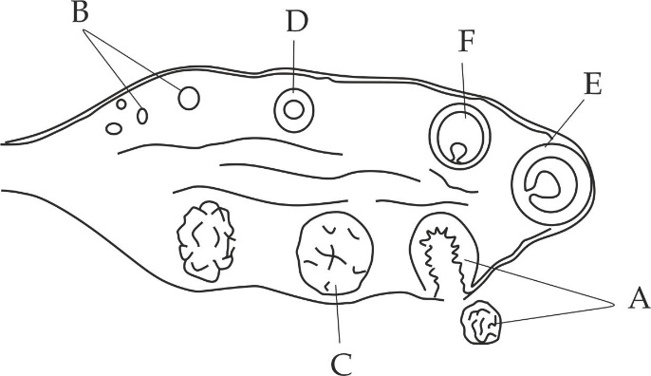

Name the and rearrange the correct sequence of structure labelled A, B, C, D, E and F

**Structure of a human egg cell (ovum)**

Structurally, an ovum is multi-layered cell which is divided into the following differentiated main layers – corona radiata, zonapellucida, cell membrane and cytoplasm.

1. **Corona radiata**

These are remains of Graafian follicle which protect the ovum against the physical and chemical damage.

1. **Zonapellucida**

It is a jelly like layer which is secreted by granulosa cells to protect the ovum against physical and chemical damage.

1. **Cell membrane**

It is a layer beneath the zonapellucida which contains microvilli which increase the surface area for absorption of nutrients from the follicle cells.

1. **Cytoplasm**

It contains cortical granules which form fertilizing membrane to prevent polyspermy during fertilization; haploid nucleus which carriers the hereditary materials from the maternal and food reserves such as lipid droplets to nourish the developing embryo.

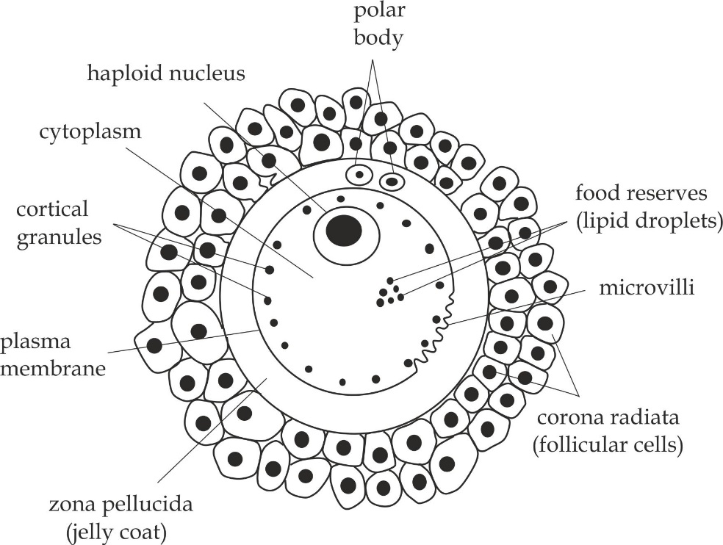

**Figure 2.23** structure of an ovum

**Adaptations of an ovum to its functions**

1. **Presence of nucleus**

It carriers the hereditary materials from the maternal to the offspring.

1. **Presence of zonapellucida**

It protects the ovum against physical and chemical damage.

1. **Presence of microvilli**

It increases the surface area for reabsorption of nutrients from the follicle cells.

1. **Presence of cortical granules**

It forms hard layer of fertilizing membrane which prevents polyspermy during fertilization.

1. **Presence of food reserves**

It contains nutrients that nourishes the developing embryo.

1. **Presence of receptor sites**

They are sites for recognition and binding of sperm during fertilization.

1. **Presence of chemicals**

They attract sperms toward itself by chemotaxis during fertilization.

**SAQ 2.12**

**NECTA 2003**

* Draw a well labelled diagram of a human egg cell.

**Table 2.3 Differences between the spermatozoa and the ovum**

|  |  |
| --- | --- |
| **Spermatozoan** | **Ovum** |
| It is a male reproductive cell | It is a female reproductive cell |
| It is relatively smaller in size.i.e, 25 µm in diameter | It is relatively larger in size.i.e. 100 µm in diameter |
| It is flagellated hence motile | It is non flagellated |
| It has large nucleus and very small portion of cytoplasm | It has small nucleus and very large portion of cytoplasm |
| It has large number of mitochondria | It has small number of mitochondria |
| It is a single layered cell | It is multi-layered cell |
| It has acrosome | No acrosome |
| No microvilli | It has microvilli |
| No food reserves | It has food reserves |
| It is straight in shape | It is ovoid in shape |

**Similarities between the spermatozoa and the ovum**

1. Both have haploid nuclei
2. Both are reproductive cells
3. Both are produced by the process of meiosis

**SAQ 2.13**

**DAR MOCK 2017**

* In what important way is the structure of the egg cell similar to that of the sperm?
* Summarizes the important differences between sperm and egg.

**Table 2.4 the differences between spermatogenesis and oogenesis**

|  |  |
| --- | --- |
| **Spermatogenesis** | **Oogenesis** |
| It produces male gametes | It produces female gametes |
| It occurs in the testes | It occurs in the ovaries |
| It starts at puberty and continuous throught the life | It starts before birth and continuous until menopause |
| It forms four functional daughter cells from a single spermatogonium | It forms one functional daughter from a single oogonium |
| No formation of polar bodies | There is a formation of polar bodies |
| Meiosis II occurs immediately after meiosis I | Meiosis II occurs after the entry of sperm |

**Similarities between spermatogenesis and oogenesis**

1. They both occur in the germinal layers of gonads.
2. They both involve three phases; multiplication, maturation and growth.
3. They both produce haploid gametes.
4. They both involve meiosis I and meiosis II.

**2.2.3 FEMALE REPRODUCTIVE CYCLES**

Reproduction in female animals is accompanied by a series of reproductive cycles. These involve cyclic changes that occur simultaneously in the uterus and the ovaries. These reproductive cycles start at the onset of sexual maturity throught the entire fertile period in the life cycle and when the animal is not pregnant. The two types of reproductive cycles are **oestrous** and **menstrual cycles**. Both cycles are controlled by the hormones released by the pituitary gland and ovaries; absence or lack of these hormones inhibits female reproductive cycles.

**Oestrous cycle**

Oestrous cycle is the reproductive cycle which involves the total time taken for the development and degeneration of the follicle cells to release secondary oocyte. It is found in most mammalian females except primates such as apes, monkeys and human .beings. Menstruation does not occur in these animals and it is usual to refer to their sexual cycle as the oestrous cycle. Animals with one oestrous cycle per year are called **monoestrous (**Fox, dog, wolf**)** while animals with more than one oestrous cycle per year are called **polyoestrous** (pigs, horses, sheep and cows).

**Phases of oestrous cycle**

The oestrous cycle has four main phases, which are pro – oestrous, oestrous, metestrus and dioestrus.

1. **Pro – oestrous**

It is the latent phase of development and maturation of one or several follicles of the ovary. It can last for a short period such as one day or for a long period such as three weeks depending on the type of the species. In this phase the female is not sexually receptive and it is characterized by the following events; **Firstly**, The old corpus luteum degenerate as the result progesterone level declines; **secondly**, the follicle cells start to secrete oestrogen which stimulates the expansion of uterus, vagina and its glands to secrete a thick mucus.

1. **Oestrous**

Oestrous come from the Greek word *oistos* meaning ‘mad desire’ and the animal is described as being ‘on heat ’.It is an active period when female become sexually receptive, i.e. ready to receive male and it is normally characterized by the following events; **Firstly**, The follicle cells become full matured as graafian follicles and releasing the secondary oocytes for fertilization, this is called fertilization; **secondly**, The oestrogen hormone reach to the peak and stimulates female sexual behaviour called **lordosis reflex**  which are presented by the changes in internal or external genitalia such as labia reddened, uterus become congested and cervix is relaxed. The oestrous phase is important because it maximizes the female sexual desire hence prepares a female to receive a male and also increase the chance for fertilization to occur since it synchronize period of ovulation with copulation.

1. **Metestrus**

This is the phase after oestrus (post- oestrus) which is characterized by the activity of the corpus luteum, which produces progesterone. The sign of oestrogen stimulation drop in this phase and there is a reduction in the amount of secretion from the uterus, cervix and vaginal glands.

1. **Dioestrus phase**

This is a period of sexual inactivity between recurrent periods of oestrus. During this phase, if pregnancy fails, this phase ends with the dispose of the corpus luteum. The lining in the uterus is not discarded instead it is recognized for the next cycle.

**Key point**

**Anoestrus phase** occurs when the sexual cycle rests during which there is no any visible sexual activity. Unfortunately, many polyoestrous mammals do not have this period for their reproductive cycle. For such mammals, their oestrus cycle has only four phases.

**SAQ 2.14**

**NECTA 2013**

* Define the term oestrus.
* Explain the stages of the oestrus cycle.
* State the significance of oestrus.
* Distinguish oestrus cycle from menstrual cycle.

**Menstrual cycle**

Menstrual cycle is a period of uterine changes between one menstruations to another. This cycle occurs in human beings and other primate mammals such as monkey, chimpanzees. Gorilla and apes. In human beings this as a 28 – day cycle controlled by hormones secreted by the pituitary gland and ovary. The function of the menstrual cycle is to stimulate the development of an egg cell in the ovary and prepare the uterus for implantation and feeding a zygote.

**Events of menstrual cycle**

The menstrual cycle involves a synchronised recurring sequence of changes in the ovaries (the **ovarian cycle**) linked to a sequence of changes in the lining of the endometrium lining of the uterus of the non-pregnant female (the **uterine cycle**).

1. **Ovarian cycle**

It is a sequence of changes in the ovaries during the menstrual cycle. The ovarian cycle involves three phases, which are follicular, ovulation and luteal phase. It is controlled by the pituitary hormones which are follicle stimulating hormone (FSH) and lutenizing hormone (LH) as indicated in Figure 2.24 (a).

**The follicular phase**

This is the first phase of ovarian cycle which involves the development and maturation of ovarian follicles in the ovary. It begins on the 1st day of menstruation until the 13rd day; it is usual characterized by the following events:

1. Releasing of FSH from the anterior pituitary gland.
2. The development and maturation of the ovarian follicles into mature graafian follicles.
3. Secretion of oestrogen from the follicle cells which has two main effects on the menstrual cycle. **Firstly**, it promotes the growth of the endometrium lining of the uterus, causing it to increase in thickness by about 0.5mm.**Secondly**, it inhibits the further secretion of FSH by the pituitary whist stimulating the pituitary to release LH.

**Ovulation**

This is the second phase of the ovarian cycle which involves the releasing of secondary oocyte (egg cell) from the mature graafian follicles. It begins at around day 14; it is characterized by the following events:

1. Releasing of LH from the anterior pituitary gland.
2. Releasing of secondary oocyte from the Graafian follicle. The process is called **ovulation**.

**The luteal phase**

This is the third phase of ovarian cycle which involves the formation and degeneration of corpus luteum. It begins on the 15th day until 28th day; it is characterized by the following events:

1. The development of follicle cells which remain in the ovary to form a corpus luteum.
2. The corpus luteum secretes small amount of oestrogen and large quantities of progesterone. These hormones work synergistically to perform two main effects on the menstrual cycle. Firstly, they inhibit further release of FSH and LH by the anterior pituitary, so that no further follicles develop. **Secondly**, they stimulate the further growth of the endometrium and its blood supply, so that it eventually reaches a thickness of about 5mm. This is very important to prepare endometrium for implantation.
3. If pregnancy (fertilization) does not occur, in the day 28, the corpus luteum disintegrate and degenerate as a scar called corpus luteum. As it degenerates, the corpus luteum stops secreting oestrogen and progesterone.

**Key points**

If pregnancy occurs after mating, the structure of the corpus luteum is maintained for the first three months by the hormone called human chorionic gonadotrophins (HCG) secreted by a developing embryo which is function is taken over by the placenta. This explain why a surgical removal of ovaries during the first three months of pregnancy will lead to a **miscarriage**.

1. **Uterine cycle**

It is a sequence of changes in the endometrium lining of the uterus during menstrual cycle. The uterine cycle has three main phases which are menstruation, proliferative and secretory phase. It is controlled by the ovarian hormones which are oestrogen and progesterone as indicated in Figure 2.24 (b).

**Menstruation**

This is the first phase of uterine cycle which is characterized by the decline in the progesterone and oestrogen level in the blood stream causing the shedding of endometrium lining of the uterus and blood tissues through the vagina during menstruation period is called a menstrual flow. The discharged substance during this period is normally as collectively called **menses** and normally takes 3 to 5 day.

**Proliferative phase**

This is the second phase of the uterine cycle that normally corresponds to the follicular phase of the ovarian cycle. It occurs during 6th to 13th day and it is characterized by an increased production of oestrogen by the ovarian follicles which has two roles. **Firstly**, it stimulates the growth and proliferation of endometrium lining of the uterus. **Secondly**, it stimulates the crypts in the cervix to produce fertile cervical mucus. This prepare the uterus for ovulation that occurs in the 14th day of a normal cycle.

**Secretory phase**

It is the final phase of the uterine cycle that corresponds to the luteal phase of the ovarian cycle. It occurs during 15th to 28th day, it is normally characterized by an increased production of progesterone by the corpus luteum which has three roles. **Firstly**, it stimulates the growth of the endometrium lining of the uterus in preparation for implantation of the blastocyst, and hence, supportive to the early pregnancy. **Secondly**, it stimulates the secretion of mucus from peritubular glands. **Lastly**, it increases blood flow into the uterine walls and reduces the contraction capacity of the smooth muscles in the uterus.

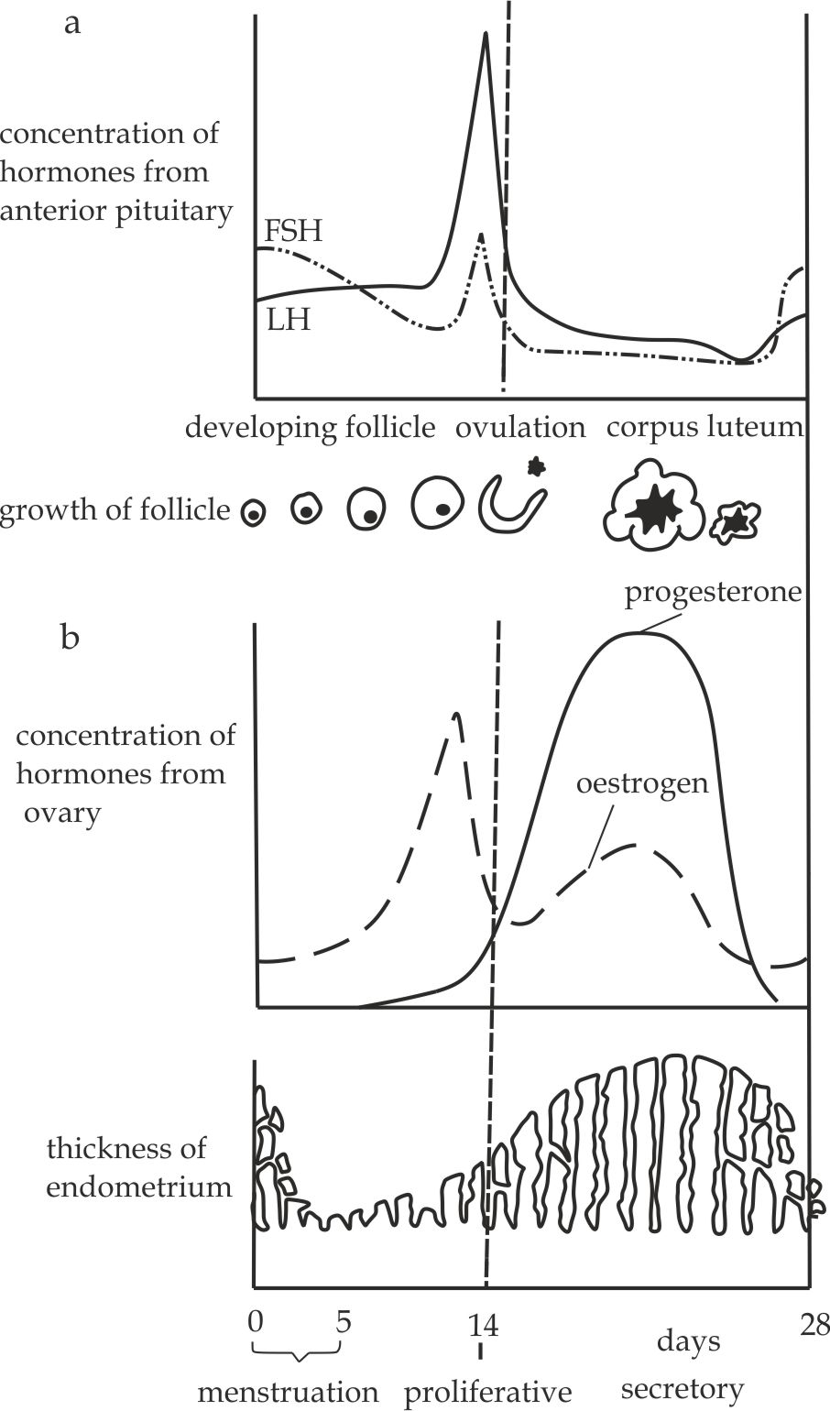

**Figure.2.24 (a), (b)** The events of human menstrual cycle

**Hormonal control of menstrual cycle**

1. At the start of the menstrual cycle, **gonadotrophins releasing hormone** **(GnRH)** is released by the hypothalamus and stimulates the anterior pituitary to release FSH as shown in Figure 2.25.
2. **FSH** travels through the blood stream to its target (ovaries) where it stimulates the development and maturation of follicle cells. Only one will complete development into a mature follicle in each month; meanwhile the cells of the developing follicles start to secrete the **oestrogen** which diffuse into the blood stream to its targets (uterus and anterior pituitary gland).
3. In the uterus, oestrogen repair the endometrium lining of the uterus for a possible implantation.
4. In the pituitary gland, oestrogen inhibits the further secretion of FSH so that no more follicles are developed, and is an example of **negative feedback mechanism.**
5. The high and rising level of oestrogen suddenly stimulate the anterior pituitary gland to produce **LH** which diffuses into the blood stream to the ovary, in the ovary; LH stimulates **ovulation** and converts the empty follicles into a ductless gland called **corpus luteum**, which secrete large quantities of **progesterone** hormone and, to a lesser extent, **oestrogen** hormone, These hormones diffuse into the blood stream to its targets (uterus and anterior pituitary gland).
6. In the uterus, they continue to stimulate the growth of endometrium, further preparing for a possible implantation.
7. In the anterior pituitary gland, they inhibit further secretion of LH and also FSH; this is a second example of **negative feedback** **control**.
8. The levels of FSH and LH in the blood stream now rapidly decrease. Low levels of FSH and LH allow corpus luteum to degenerate into corpus albicanti. As a consequence, the level of progesterone and oestrogen also fall causing shedding of the endometrium, blood tissues and unfertilized egg through the vagina in the first five days as a **menstrual flow.**

**Treating infertility**

* In some women the pituitary fails to produce enough FSH, with the result that Graafian follicles do not develop in the ovary and ovulation does not occur. This can be remedied by **injection of** **FSH** or a synthetic equivalent, the so – called **fertility drug.**
* Some women fail to ovulate because they secrete too much oestrogen which has the effect of inhibiting FSH secretion by the pituitary. They can be treated with non – steroidal drug such as **clomiphene** which oppose the action of oestrogen.

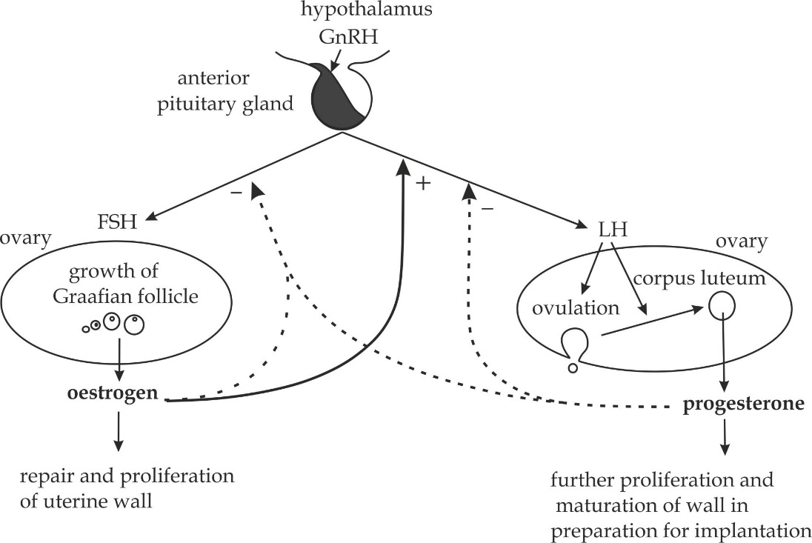

**Figure 2.25** scheme summarising the main interaction of hormones controlling the female sexual cycle. Solid arrows and positive sign signify stimulation, broken arrows and negative signs signify inhibition.

**SAQ 2.15**

**NECTA 2000**

* Discuss the hormonal interaction involved in the control of the menstrual cycle in human female.
* In what way is menstruation prevented if pregnancy occurs?

**The roles of hormones involved in the menstrual cycle**

1. **Follicle stimulating hormone (FSH)**
2. It stimulates the development and maturation of ovarian follicle cells.
3. It stimulates the follicle cells to secrete oestrogen.
4. **Lutenizing hormone (LH)**
5. It causes ovulation, i.e. the releasing of secondary oocyte from the mature follicle cells.
6. It converts mature follicle cells (Graafian follicle) into corpus luteum which secrete progesterone.
7. **Oestrogen**
8. It repairs the uterine wall in preparation for implantation.
9. It inhibits anterior pituitary gland to release FSH, so that no follicle developed.
10. It stimulates anterior pituitary gland to release LH.
11. **Progesterone**
12. It inhibits FSH secretion and therefore stops further ovarian follicles developing (*a fact made use of in the developing of the contraceptive pill).*
13. It stimulates the development of the uterine wall.
14. It stimulates glandular activity to secrete a thick mucus.

**SAQ 2.16**

**KILIMANJARO MOCK 2018**

* Briefly describe the roles of the following hormones:

1. Follicle stimulating hormone (FSH)
2. Lutenizing hormone (LH)
3. Progesterone
4. Oestrogen

**Table 2.15 Differences between menstrual cycle and oestrous cycle**

|  |  |
| --- | --- |
| **Menstrual cycle** | **Oestrous cycle** |
| It is a period of uterine changes from one menstruation to another | It is a period for the development of the follicle cells to release eggs |
| It usual begins at puberty and stop at menopause | It begins at puberty and continues throughout the life |
| It occurs in primate mammals only such as human beings and monkeys | It occurs in non-primate mammals such as cows, dogs, horses,etc. |
| It occurs in the uterus and ovaries | It occurs in the ovaries only |
| It is accompanied with discomfort | No discomfort period |
| Female does not permit copulation during menstrual phase of the cycle | Female permits copulation only during oestrous phase |
| Females can be sexually active any time in their cycle | Females are only sexually active during the oestrous period |

**SAQ 2.17**

**DAR MOCK 2021**

* How oestrous differs from menstrual cycle?

**2.2.4 CAPACITATION**

Capacitation is a time taken during which the sperm undergoes activation process in the female genital tract before fertilizing the secondary oocyte. In other word. It is the final part of the sperms maturation process. It takes for about 7 hours and involves the number of changes including:

1. Removal of plasma protein and glycoprotein layer from the sperm surface by uterine enzymes.
2. Removal of cholesterol from the sperm head membrane by the uterine enzymes for easy penetration of acrosomal enzymes
3. The sperm membrane becomes more permeable to calcium ions which has the dual functions; increasing beating activity of the sperm tail a promoting the acrosomal reaction.

**SAQ 2.18**

**NECTA 2017**

* Briefly explain the concept of capacitation and as it is related to reproduction.

**2.2.5 FERTILIZATION**

Fertilization is the process whereby the nucleus of a male gamete fuses with the nucleus of a female gamete to form the diploid nuclei, known as a **zygote**. This process normally takes place in the fallopian tube of a female.

**Importance of fertilization in sexually reproducing animals**

1. **It maintains the constant number of chromosomes**

This is because; during gametogenesis, meiosis reduces the number of chromosomes to a half (haploid), whereby fertilization helps to restore the usual diploid number of chromosomes in a given species.

1. **It brings about variation**

This is because, it combines the characteristics of two parent’s thereby inducing variations through genetic recombination, which make the offspring better adapted to struggle for existence.

1. **It stimulates the maturation of secondary oocyte.**

This is because, the maturation of secondary oocyte into an ovum (egg cell) is completed only after the entry of the spermatozoan in it during fertilization.

**Mechanism of fertilization**

The mechanism of fertilization process involves two major events, which are **acrosomal** **reaction** and **cortical reaction**.

**Acrosomal reaction**

Acrosomal reaction is the process whereby an acrosome from the sperm head rupture and releasing hydrolytic enzymes which digest the outer egg walls. That is to say; it involves the changes and actions of acrosome enzymes. The hydrolytic enzymes are of two main types, **firstly**, the hyaluronidase enzymewhich digests tough corona radiata, the remains of graafian follicles, which are found at the surface of the secondary oocyte. **Secondly**; the protease enzyme which digest zonapellucida, the thick layer of granulosa cells beneath the corona radiata of secondary oocyte as shown in Figure 2.26.

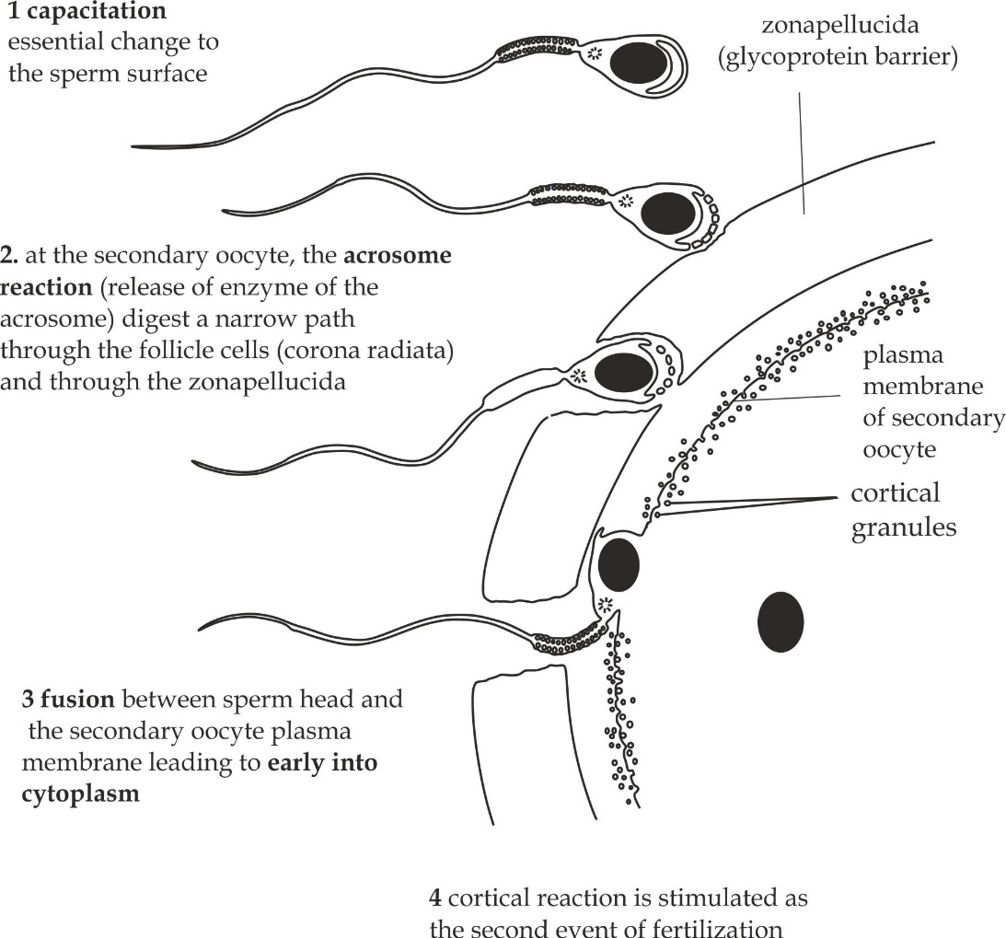

**Figure 2.26** the acrosomal reaction

**Cortical reaction**

Cortical reaction is the process whereby the cortical granules from the secondary oocyte rupture and releasing lysosomes during fertilization. That is to say; it involves changes that take place in the cortical granules and the action of their lysosome enzymes; the lysosome enzymes have two main functions, **firstly**, they catalyse the formation of fertilizing membrane by hardening the zonapellucida. Which prevents multiple fertilization of the secondary oocyte. This is called a block to **polyspermy**. **Secondly**, they destroy the spermatozoa receptor sites on the zonapellucida so that the other incoming spermatozoa cannot bind to the secondary oocyte. Prior to entry of the spermatozoan, the nucleus of the secondary oocyte is stimulated and complete its meiosis II to produce ootid and second polar body. The ootid matures into an ovum and the second polar body immediately degenerate. At the same time, the tail of the spermatozoan is lost within the cytoplasm of the ovum. During this process stage, the chromatin in the nucleus of the spermatozoan become loose and this results into bulging of the nucleus. The swollen nucleus is called a pronucleus.The nucleus of the ovum also become a pronucleus.In this process of fertilization, the two proniclei fuse to form a diploid zygote as indicated in Fig 2.27 .

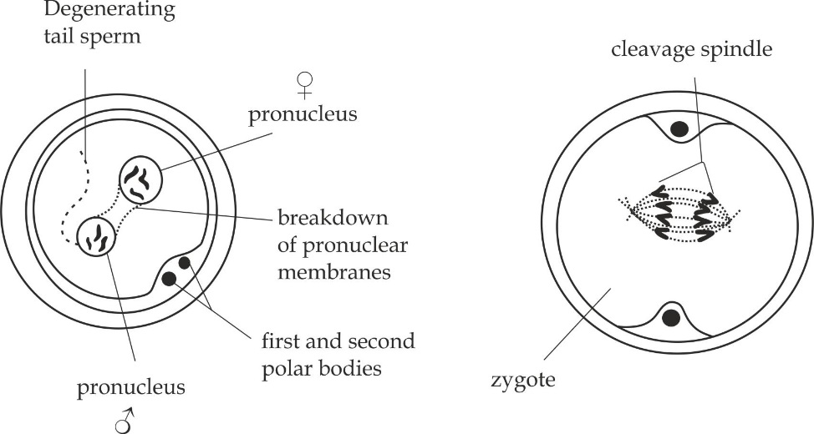

**Figure 2.27** cortical reaction

**SAQ 2.19**

**EZEB 2012**

* Write a briefly description of the events which takes place during fertilization in human.
* What change occurring in the secondary oocyte after penetration of the sperm cell?
  + 1. **EMBRYONIC DEVELOPMENT**

The study of embryonic development is called embryology, which is divided into three main stages.

* Cleavage
* Blastulation
* Gastrulation

**Cleavage**

Cleavage is a process whereby a zygote undergoes repeated mitotic division to form a solid mass called the **morula**. The cells which are formed are called *blastomeres*. Cleavage process in human has three main properties. **Firstly**; it is indeterminate, this is because it starts from a unicellular zygote and undergoes continuously mitotic division to form a morula. **Secondly**; it is radial, this is because, it gives two equal parts at any plane of cell division. **Moreover**; it is fixed, in a sense that; the size of the zygote during cleavage does not increase because it is still bounded by the hard layer of zonapellucida. While cleavage is taking place, the morula is in the oviduct moving slowly toward the uterus by the action of cilia in the oviduct while the Blastulation starts as indicated in Figure 2.28.

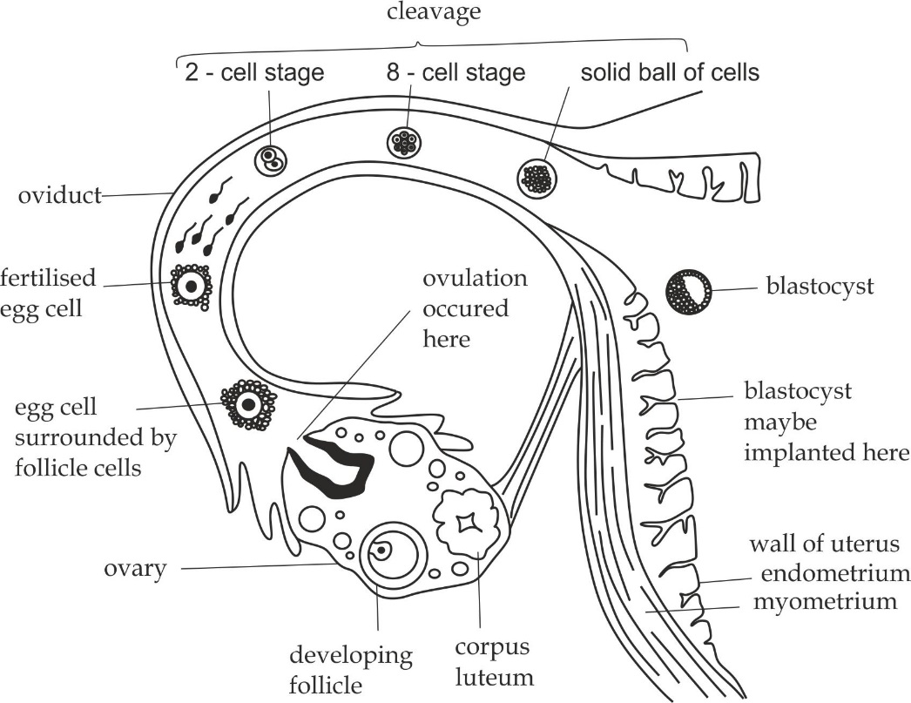

**Figure 2.28** embryonic development illustrating cleavage process

**SAQ 2.20**

**JECAS 2011**

* Explain briefly how morula is formed from the zygote.
* What do you understand by the statement ″ the formation of morula from the zygote is radial and indeterminate?

**Blastulation**

Blastulation is a process whereby a morula changes into a ball of cells with a fluid filled cavity called the **blastula** (blastocyst*)*. In human, it takes for about 6 days after fertilization. During this process; the cells in the centre of the morula migrate and accumulate at one end where they form an inner cell mass as indicated in Figure 2.29 a, the result of this cellular migration is the is formation of a central fluid filled cavity, which is called a **blastocoel**. The whole structure now is called a **blastocyst** or **blastula**. The outer layer of the blastula is known as the **trophoblast** and it is made up of trophoblastic cells which secrete a hormone called human chorionic gonadotrophin (HCG).This hormones help to maintain the structure of corpus luteum to ensure a continuous secretion of progesterone and oestrogen in order to maintain pregnancy for the first 3 months.

**Implantation**

It is the attachment of the blastocyst to the endometrium lining of the uterus. It takes from day 7 to day 14 approximately.

**Mechanism of implantation**

* When the blastula arrives in the uterus, the zonapellucida is peeled off by the enzymes in the uterus and disappears in two days.
* The portion of the blastocyst where the inner mass is located lies against the endometrium of the uterus and come into contact with endometrial cells, whereby the trophoblastic cells differentiate into outer chorion layer and inner amnion layer.
* The chorion develops fingers like structures called chorionic villi, which grow into endometrium which surrounded by maternal blood in a system of sinuses called **lacunae**. Nutrients are made available to the developing embryo through these structures. Later this duty is taken over by a new structure, the placenta.
* Meanwhile the inner mass differentiate into two cell layers known as bilaminar embryonic disc; the outer hypoblast surrounding the yolk sac and inner epiblast surrounding the amniotic cavity as shown in figure 2.29 b.

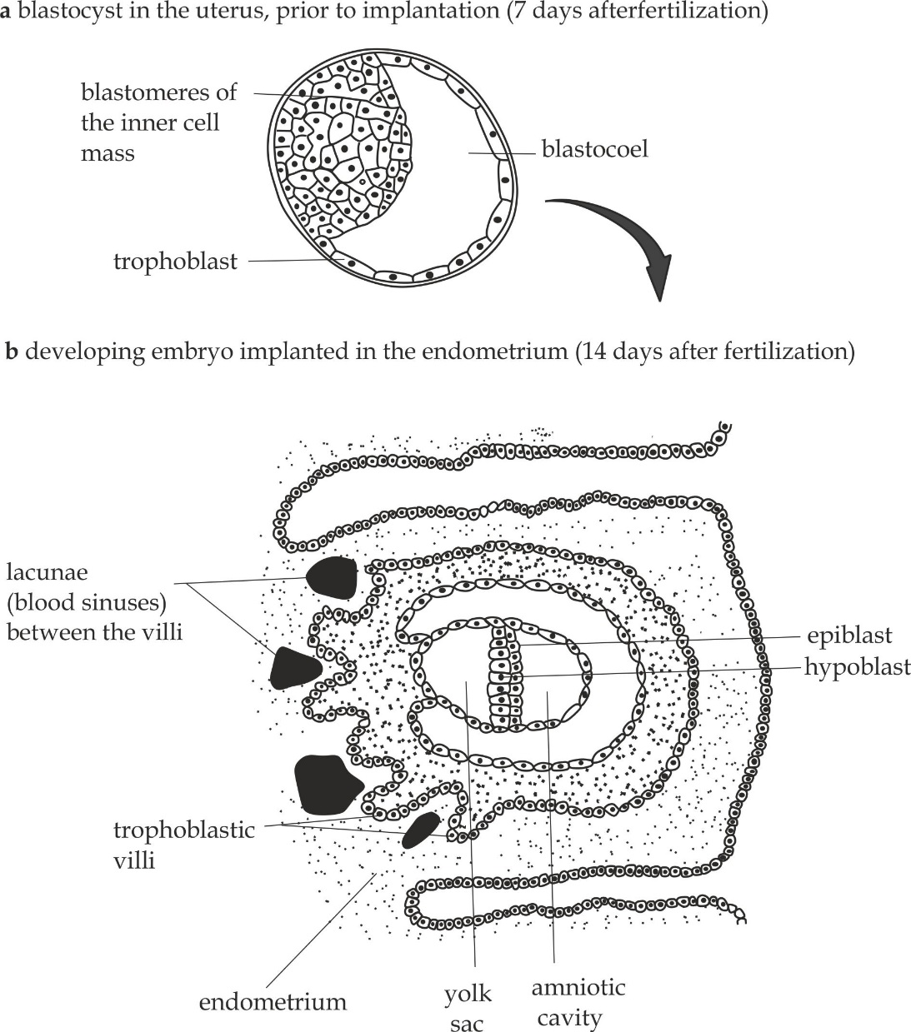

**Figure 2.29** a structure of a blastocyst; **2.29b** implantation of blastocyst

**SAQ 2.21**

**JECAS 2018**

* Define the following terms:

1. Cleavage
2. Blastulation
3. Gastrulation

* Describe the mechanism for the formation of a blastocyst from morula in human being.
* Draw the structure of a human blastocyst.

**Gastrulation**

Gastrulation is the process whereby a blastocyst changes into gastrula with three primary germ layer of cells. The layers are the **ectoderm** (outer layer), the **endoderm** (inner layer) and the **mesoderm** (middle layer) between them.

**Mechanism of gastrulation**

The process of gastrulation involves the rearrangement and movement of the blastula cells into a three layer embryo. During this process, cells on the one side of the blastula invaginating forming a small pore, which is called a **blastopore**. Through this pore, about half of the cells from the outside move to the inside of the blastula. At this point, the embryo is said to turn on itself. The result of this movement is the formation of two germ layers, the outer layer called **ectoderm** and the inner layer called **endoderm**. The blastocoel becomes an **archenteron**, which is the future digestive tract. The blastopore is the future anus.Finally, the third layer, the **mesoderm** formed between the ectoderm and endoderm formed in the developing embryo as indicated in the figure 2.30.The cells forming a particular germ layer determine its fate as the embryo continue to develop. The endoderm forms parts such as the liver, pancreas, the lining of digestive tract as well as respiratory systems. The mesoderm forms bones, muscles, excretory, circulatory 9heart, blood vessels, blood, lymphatic system) and reproductive systems. The ectoderm forms nervous system, epidermis of the skin and its associated structures such as hairs, nails and glands.

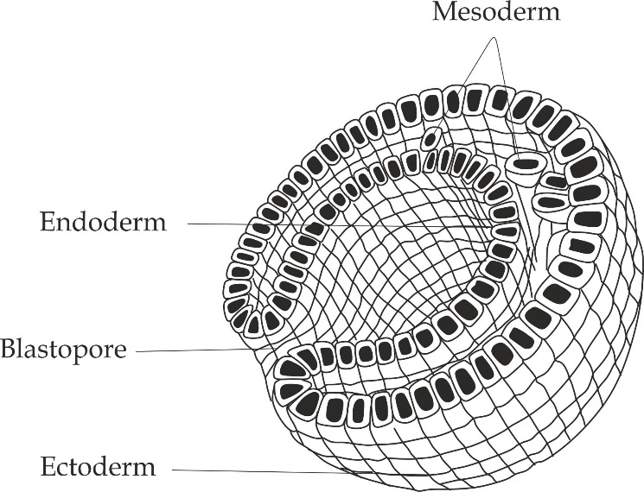

**Figure 2.30** development of a gastrula

**SAQ 2.22**

**TAHOSSA 2022**

* The gastrulation is three layered embryo.

1. Name these layers
2. State the role of each layer.
   * 1. **EXTRA EMBRYONIC MEMBRANES**

These are membranes outside the embryo formed after the implantation. There are four types of extra embryonic membranes which are chorion, amnion, yolk sac and allantoin as indicated in Figure 2.31.

1. **Chorion**

This is the outermost membrane derived from the trophoblastic cells. It forms the chorionic villi, the finger like projections that grow into endometrium. It performs the following roles:

* It protects the developing embryo against physical damage.
* It nourishes and removing excretory wastes from the embryo.
* It involves in the formation of placenta.

1. **Amnion**

This is the innermost membrane, surrounds a fluid filled cavity, the amniotic cavity which contains **amniotic fluid** secreted by the amniotic cells. The amniotic fluid performs the following roles:

* It acts as a shock absorber.i.e, it protects the fetus from damage by external injury.
* It allows the fetus to move freely within the uterus.
* It maintains stable foetal body temperature.

1. **Yolk sac**

This has got no obvious function in human’s embryo, and later become buried in the placenta. In reptiles and birds, however, the yolk sac is the structure by which the developing embryo obtains food from the yolk.

1. **The allantois**

This is the sac like outgrowth that develops from the embryonic hind gut. The allantois grows in close contact with the chorion, at this stage, the allantois develops into a structure containing numerous blood vessels than chorionic villi. This structure is called allanto – chorion, which later develops into the **placenta.** The stalk of the allantois also contributes to the formation of the **umbilical cord** which links the embryo to the mother.

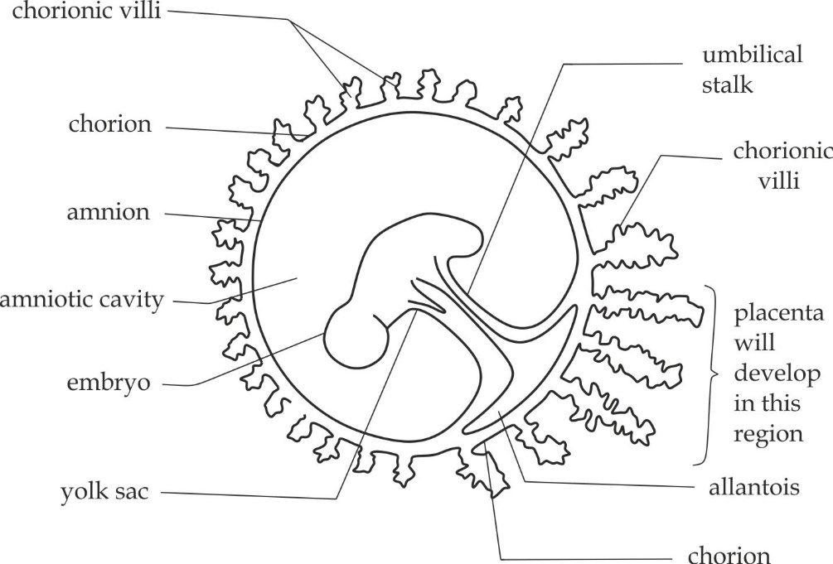

**Figure 2.31** human embryo and embryonic membranes

**SAQ 2.23**

**JECAS 2016**

* Identify the embryonic membranes in mammals and state the role of each.

**2.2.8 THE PLACENTA**

The placenta is a large structure for exchanging of materials between the mother and the foetus. The placenta develops 12 weeks after conception. The placenta is found in mammals only and it is the only organ with cells derived from both the foetus and the mother, which is principal the two different organisms.

**Structure of the placenta**

Structurally, the placenta is composed of the tissues of two different organisms; tissue of the mother’s endometrium and from the tissues of foetal membranes (the chorion and the amnion).In the placenta the maternal blood is brought close to that of the foetus, but they normally do not mix. Fingers like projections of the allanto – chorion grow into the endometrium, and become bathed by maternal blood of the sinuses (lacunae) as indicated in Figure 2.32.

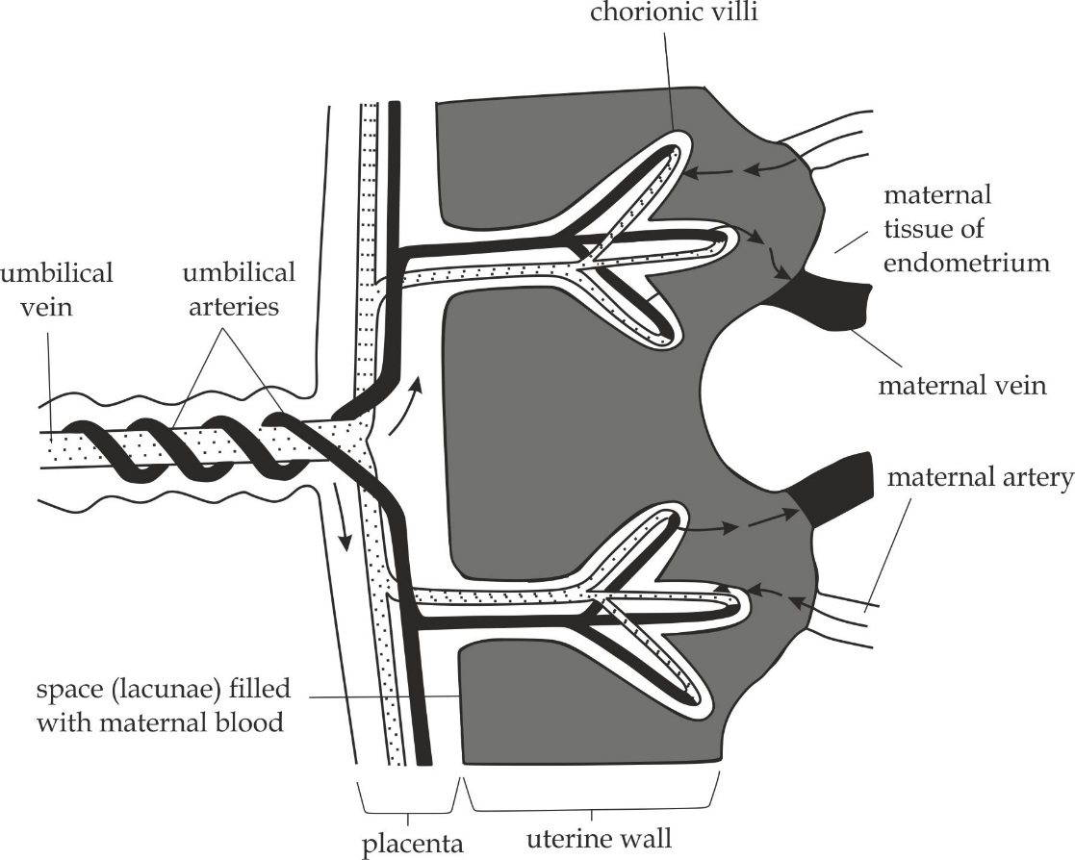

**Figure 2.32** the mammalian placenta

**Functions of the placenta**

The placenta serves as a link, endocrine organ and barrier as follows:

1. **Placenta as a link**

The placenta functions as a link by allowing exchange of materials between the mother and foetus as follows:

1. **Nourishing function**

It allows the passage of nutrients from the mother to the foetus. **Water**, which crosses the placenta by osmosis; **glucose** which crosses by facilitated diffusion; and **ions**, **lipids**, **vitamins** and **amino acids**, which are transported actively.

1. **Respiratory function**

It allows the exchange of respiratory gases between the mother and foetus. Oxygen, needed for aerobic respiration diffuses from the mother’s blood to the foetal blood; whereas carbondioxide as a waste product of aerobic respiration diffuses in the opposite direction from the foetal blood into the mother’s blood.

1. **Excretory function**

It allows the passage of excretory products such as urea from the foetus to the mother.

1. **Placenta as endocrine organ**

The placenta as endocrine organ secretes the following hormones of the pregnancy as shown in Figure 2.33.

1. **Human chorionic gonadotrophin (HCG)**

* It maintains activity of corpus luteum to produce progesterone and oestrogen for the first 12 weeks of pregnancy.

1. **Oestrogen**

* It stimulates the development of duct system of breast.
* It inhibits release of FSH from the anterior pituitary gland.
* It inhibits release of prolactin from the anterior pituitary gland.
* It maintains endometrium lining of the uterus.
* It increases the sensitivity of myometrium to oxytocin.

1. **Progesterone**

* It stimulates the development of milk glands in breast ready for lactation.
* It inhibits release of FSH from the anterior pituitary gland.
* It inhibits release of prolactin from the anterior pituitary gland.
* It maintains the endometrium lining of the uterus.
* It inhibits the contraction of myometrium to prevent miscarriage.

1. **Human placental lactogen (HPL)**

* It stimulates growth and development of breast.

**Disorders of pregnancy**

Progesterone also relaxes the lower oesophageal sphincter, bladder sphincter and the gastric muscles and the intestine, these effects account for some minor disturbances of pregnancy, for example heart burn, frequency in urination; delay in stomach emptying and reduced peristaltic activity leading to constipation which may result into haemorrhoids (bawasili) in pregnancy.

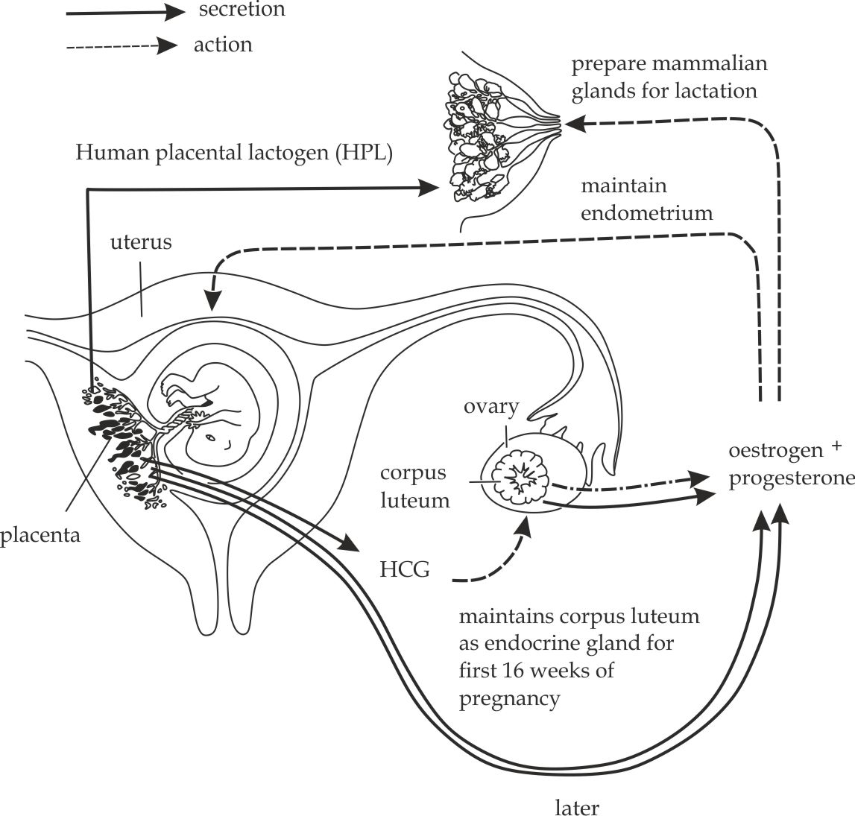

**Fig 2.33** Actions of the female hormones during pregnancy

1. **Placenta as a barrier**

The placenta functions as a barrier by preventing some materials to enter the body of the foetus from maternal body as follows:

1. It protects the foetus by preventing the irregular movement.
2. It protects the foetus by proving antibodies from the mother.
3. It protects the foetus by preventing blood mixing.
4. It protects the foetus by preventing high maternal blood pressure.
5. It protects the foetus by acting as a shock absorber.
6. It protects the foetus by filtering out some pathogens and chemicals.

**Harmful substances that may cross the placenta**

Though the placenta acts as a barrier for certain toxic chemicals but certain substances called teratogens can pass through the placenta and cause the birth defects or fetal death. Examples of teratogens including:

1. **Pathogens**

Although most bacteria are too large to cross the placenta, most viruses are small enough to do so.For example; Rubella virus *(German measles)* may cross the placenta and cause the congenital rubella syndrome (CRS) to the foetus which characterized by the following features :

* + - *Eye defects* *(cataract, glaucoma)*
* *Ear defects (hearing loss)*
* *Central nervous system defects (severe mental retardation)*

1. **Drugs**

* **Pharmaceutical drugs**

Pharmaceutical drugs contain chemicals that may cross the placenta and harm the foetus. For example; *Thalidomide* used in 1960s for the treatment of nausea and vomiting *(morning* *sickness)* in pregnancy cause the *thalidomide syndrome* which is characterized by seal limbs as shown in Figure 2.24.

*Tetracycline* antibiotics can also

produce yellowish to brown discoloration of teeth.

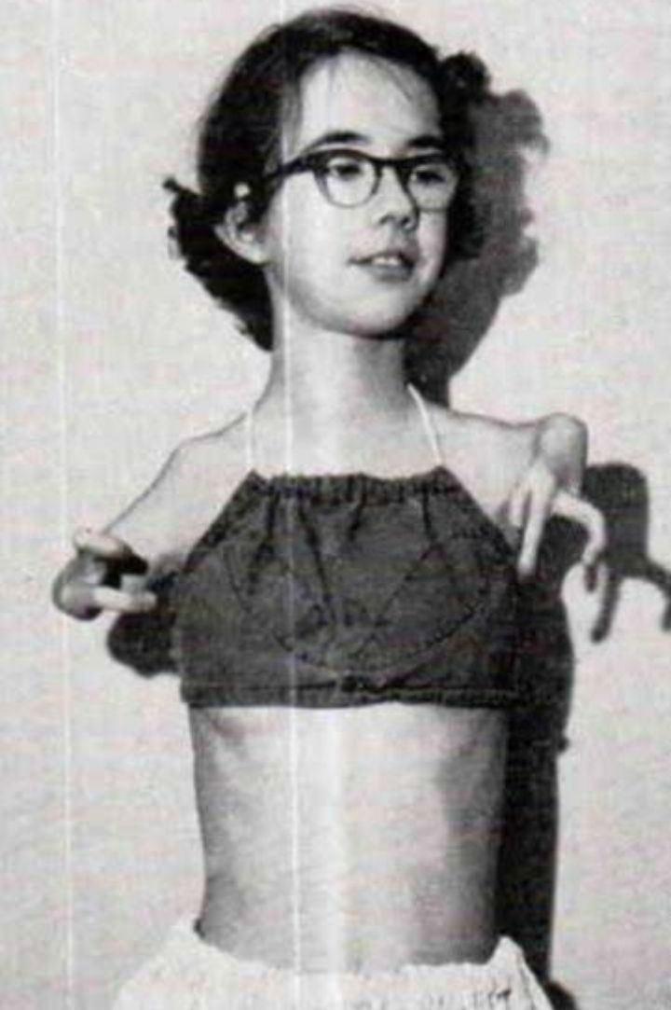

**Figure 2.24** (*phocomelia* or *seal* *limb*) thalidomide syndrome

* **Alcohol**

Heavy consumption of alcohol (binge drinking) during early pregnancy may lead to **fetal alcohol syndrome (FAS)** which is characterized by the following symptoms and signs:

* *Mental retardation.*
* *Microcephaly (small head/brain).*
* *Poor muscle tone.*
* *Fetal growth restriction.*
* *Behavioural problems such as hyperactivity or poor concentration and learning difficulties.*
* **Nicotine**

Excessive cigarette smoking (2 or more a day) during pregnancy may result into the following **fetal defects**:

* *Low birth weight (below 2000 gm.)*
* *Fetal growth restriction.*
* *Prematurity.*
* **Opioids**

Opioids such as heroine, methadone, cocaine or crack may lead into fetal addiction which is characterized by the **withdraw syndrome**.

* **Cannabis**

Cannabis such as harsh and marijuana may lead into **fetal growth** **restriction**.

1. **Rhesus factor**

The Rhesus factor is an antigen found in the cell surface membrane of red blood cells.84% people possess the factor and are described as **rhesus** **positive (Rh+).** Those who do not have are described as **rhesus negative** **(Rh-).** A problem arises if the mother is rhesus negative and the baby is rhesus positive. If red blood cells from the foetus get into the mothers circulation, her body will recognize the rhesus (D) antigen as foreign, and make **anti – rhesus (anti –D)** antibodies against them. During a second pregnancy with a rhesus positive baby, the mother’s immune system has already learnt to make anti – D antibodies. Anti – D can cross the placenta into the blood of the foetus and cause problems to the foetus called **haemolytic** **disease of the new-born**. The new-born baby suffers from acute anaemia and is very breathless as a result of shortage of oxygen; the baby’s skin also appear yellowish discoloration because of the breakdown of its haemoglobin into other pigments. Haemolytic disease used to be a major cause of death in new-born infants and was treated by replacing the child’s blood with a complete transfusion of Rhesus – negative blood in hospital.

**SAQ 2.24**

**MOROGORO MOCK 2020**

* Placenta serves as a link between foetus and mother. At the same time it acts as a barrier between them. By reference to the functions of placenta, show the statement above.

**SAQ 2.25**

**NECTA 2011**

* State four protective and two endocrine roles of the placenta in human.
  + 1. **HORMONAL CHANGES DURING PREDNANCY**

The figure 2.25 shows the changes in the blood concentration level of four hormones during pregnancy, birth and lactation. The hormones are *luteal* *progesterone, placental* *oestrogen* and *progesterone, oxytocin* and *prolactin,* its pattern of secretion can be describes as follows:

**Luteal progesterone**

Initial luteal progesterone is secreted by the corpus luteum to maintain the endometrium thickness of the uterus and finally after 10 weeks of fertilization is reduced to zero.

**Placental progesterone and oestrogen**

After 10 weeks of pregnancy, gradually the placenta takes over from the corpus luteum to secrete progesterone and oestrogen which maintain the thickness endometrium and finally prior to birth the progesterone and oestrogen are reduced to zero.

**Oxytocin**

Prior to birth, placenta starts to secrete oxytocin and its level increases rapidly to induce labour and its secretion is reduced to zero after delivery.

**Prolactin**

Prior to birth the prolactin hormone is secreted and its level become steady after birth to ensure the production of milk is high throught the lactation.

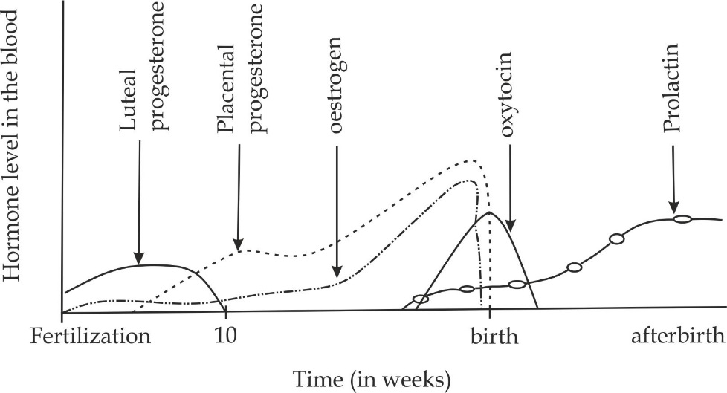

**Figure 2.25** changes of hormones during pregnancy, birth and lactation

**SAQ 2.26**

**NECTA 2OO2**

* The graph below shows the changes in the blood concentration level of hormones involved in pregnancy, birth and lactation.

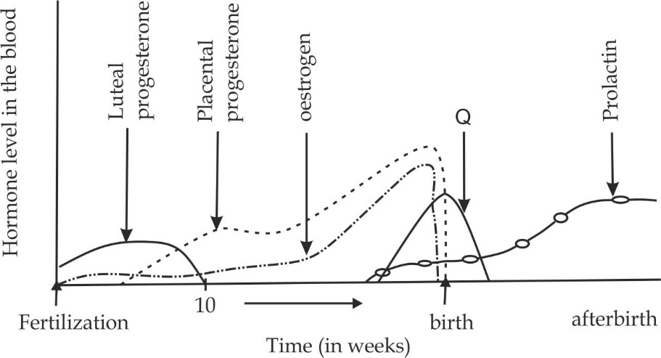

1. Comment on the patterns of secretion of the four hormones indicated on the graph.
2. Identify Q and its pattern of secretion.
3. State the roles of each of the hormone indicated on the graph.
   * 1. **BIRTH PROCESS AND PARENTAL CARE**

**Birth or parturition** is a process whereby a fully developed foetus is expelled out of the mother’s womb after the gestation period is complete. **Gestation period** is a time from conception to birth. In human it lasts approximately nine months, but in other mammals it ranges from a little as 18 days in mice to 22 months in elephants.

**Stages of birth**

The process of birth is divided into three main stages:

* The first stage of labour
* The second stage of labour
* The third stage of labour

**The first stage of labour**

**Cervical dilatation**; It involves the dilatation of cervix up to 10 cm wide, this is needed to allow the passage of the head of the baby. The first stage of labour is the longest stage which can lasts between 12 hours for first pregnancies (*primigravida*), and about 6 hours for women who have had a child previously (*multigravida*).

**Events of the first stage of labour**

The first stage of labour is initiated by the maternal body starting to reject the mature foetus as follows:

1. The hypothalamus of the fully developed foetus is stimulated to release the adrenocorticotrophic releasing hormone (ACTRH) which in turn stimulates the foetal pituitary gland to release adrenocorticotrophic hormone (ACTH) which stimulate the foetal adrenal gland to secrete corticosteroids.
2. Corticosteroids diffuses into the mother blood into the placenta whereby it decreases progesterone level and increasing prostaglandin production.
3. As the level of progesterone in the blood decreases the maternal pituitary is allowed to release oxytocin.
4. The oxytocin causes the contraction of the uterine wall while prostaglandin hormone increase further the intensity of contraction, this result into dilatation of cervix and amniotic membrane rupture to release amniotic fluid. These contractions of myometrium sum up to labour pains.
5. The contraction increase and foetus is furthermore forced to the cervix. The stage terminates when the diameter of the cervix become equal to the foetal head as indicated in Figure 2.26.

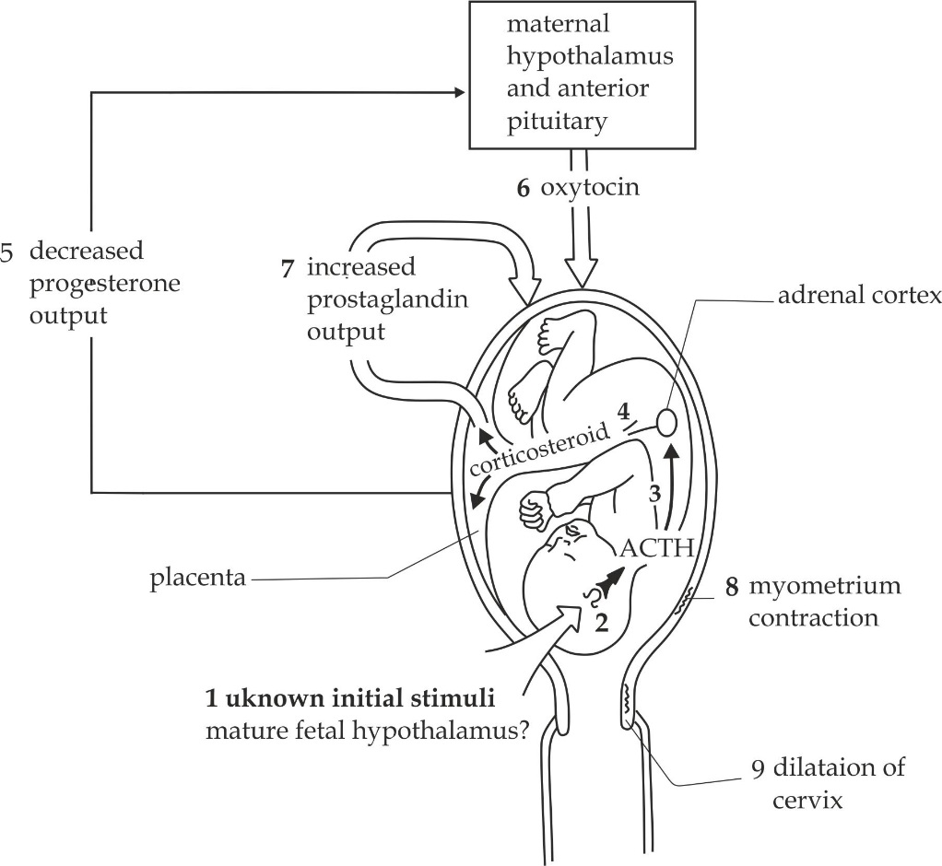

**Figure 2.26** the events of the first stage of labour

**The second stage of labour**

**Parturition**; it is a delivery of the baby, which is marked by the passage of the head and its entire body through the vagina.once the baby is out of the mother’s womb, the umbilical cord is ligatured at two points and a cut is made between the two ligatures allowing the baby to be totally separated from the mothers physiological reliance.

**The third stage of labour**

**Expulsion**; It involves the delivery of the ″ after birth “which are placenta and the associated embryonic membranes out the womb. The process occurs between 10 to 15 minutes after the delivery of the baby. This is important because if the placenta remains in the body for long time, its decomposition can lead to blood poisoning that may ultimately cause death of the mother, the condition known as **disseminated intravascular coagulopathy (DIC).**

**SAQ 2.27**

**NECTA 2004**

* Explain birth stages in mammals.

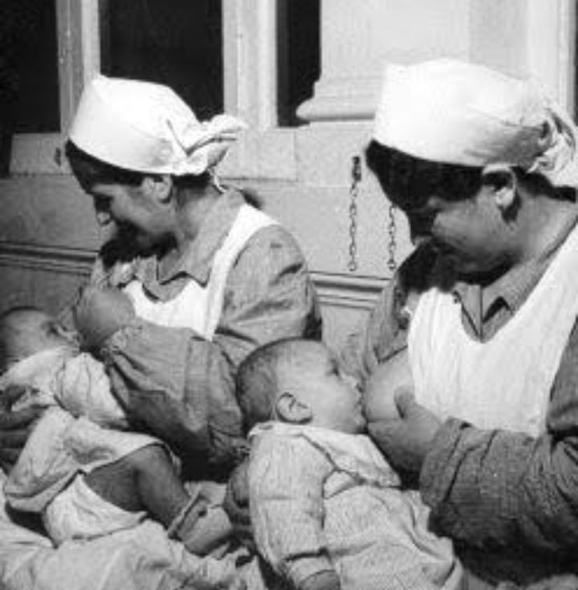

**Fig 2.27** breast – feeding helps to establish an emotional and social bond between mother and baby

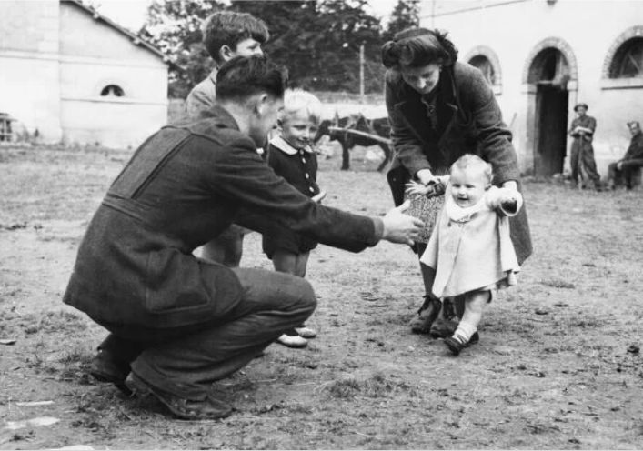

**Fig 2.27** Human parental care includes a long period of physical education

**Parental care** refers to the process in which a mother provides basic needs including food, clothing, sheltering also maximizing social relationship to the new born baby.

**The aspects of parental care**

* **Lactation**

Lactation is the production and secretion of milk from the breast. As shown in Figure 2.27.

Roles of breast milk:

1. Breast milk contains all the nutrients such as ions, sugar, proteins, and ions which are required by the baby for the good health.
2. First breast milk is known as the colostrum, contains very important antibodies that help the new born baby to fight against infection.

* **Protection**

It normally includes clothing and sheltering.

Roles of protection:

1. It provides warmth to the child, this keeps the baby healthy and away from cold.
2. It gives new born enough time to rest and grow.

* **Social interaction**

**I**t includes teaching to speak and write Figure 2.27, singing songs.

Role of social interaction:

It helps to maintain new-born mental well-being.

**SAQ 2.28**

**MOROGORO MOCK 2006**

* How parental care does increases the survival chance of the offspring in mammals.
  + 1. **MULTIPLE BIRTHS**

A **multiple birth** is the process of giving birth to more than one young from the same mother and from the same pregnancy. The most common type of multiple birth in humans is twins (two young’s), which occur about once in every 90 births. Triplets (three young’s) and quadruplets (four young’s) may occur naturally but they are very rare (90 x 90 pregnancies).

**TWINS**

Twins are two young individuals that are born from the same mother and from the same pregnancy.

**Causes of multiple births**

In humans, multiple births are due to the following factors:

1. **Application of fertility drugs**

Fertility drugs cause ovulation of more than one secondary oocytes at once (hyperovulation).Each may be fertilized by a spermatozoan and may result into multiple pregnancies, and hence, multiple births.

1. **Age of the mother**

As the mother ages increase, there is an accumulation of FSH in their blood, but the ovaries slowly respond to this hormone in turn, ovulation of more than one secondary oocyte may result.

1. **Genetic factor**

Hyperovulation is also triggered by a gene called “*twin gene*″ which cause a woman to release more than one secondary oocytes in a single reproductive cycle.

**Types of twins**

There are three (3) main types of twins, namely; Monozygotic, Dizygotic and Conjoined.

1. **Monozygotic twins**

These are also called identical twins. These are twins result from complete cleavage of the same fertilized egg (zygote).Following the first cleavage of the zygote, each blastocyst develops into an individual embryo as shown in Figure 2.29.

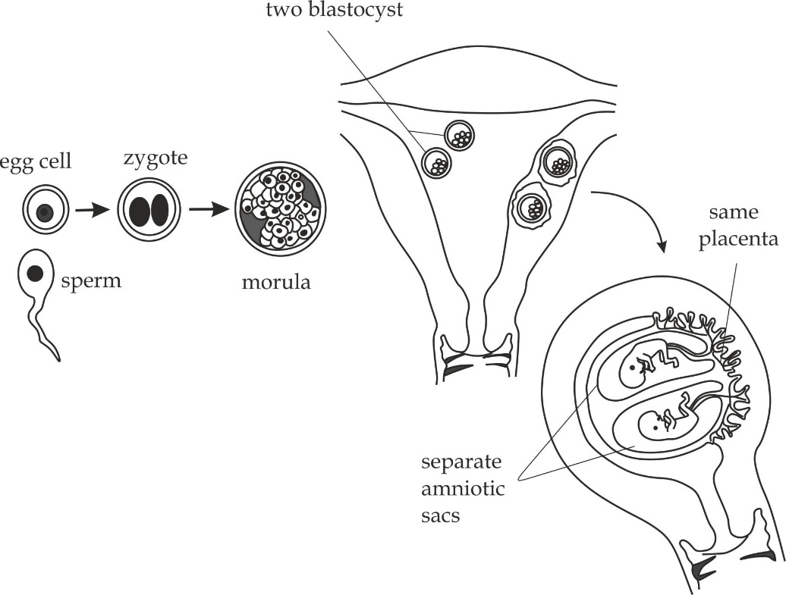

**Figure 2.29** Monozygotic twins

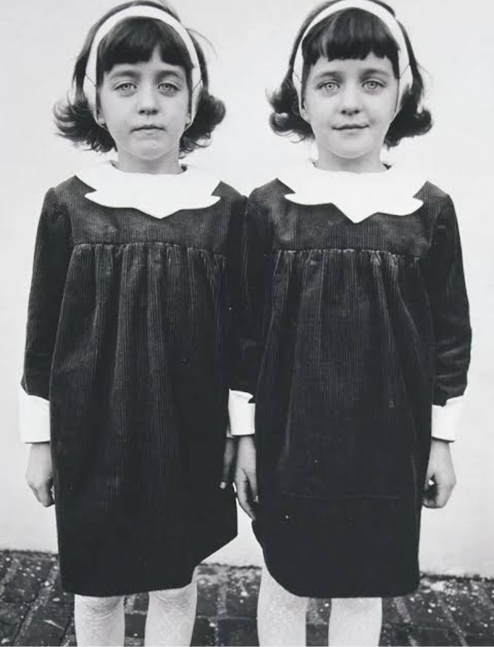

**Figure 2.30** monozygotic twins

**Features of monozygotic twins**:

* They are genetically identical.
* They are usual of the same sex as shown in Figure 2.30.
* They share the same placenta
* They are enclosed in different amniotic sacs.
* They have different amniotic membranes

1. **Dizygotic twins**

These are also called fraternal twins. These twins result from two different egg cells fertilized by two different sperms forming two different zygotes as shown in Figure 2.30.

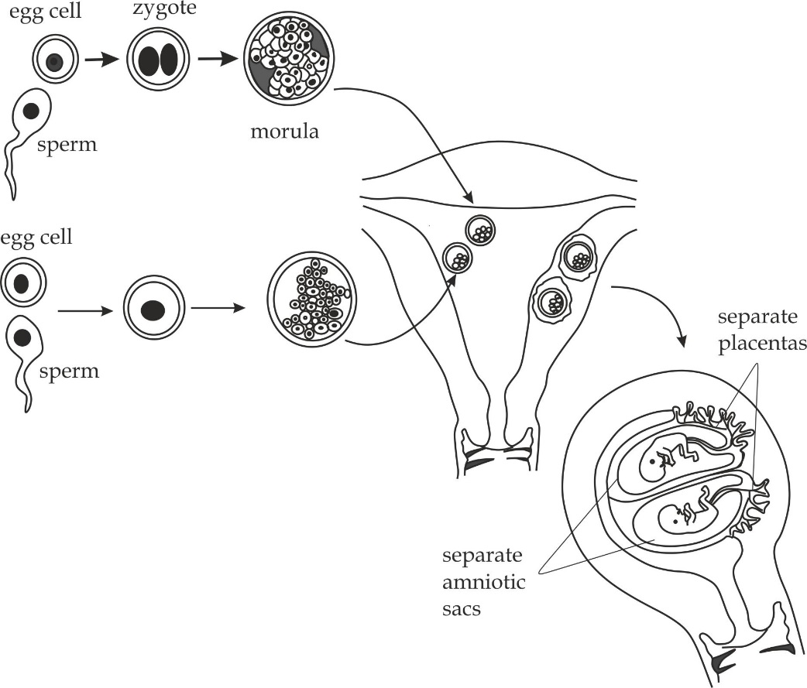

**Figure 2.30** dizygotic twins

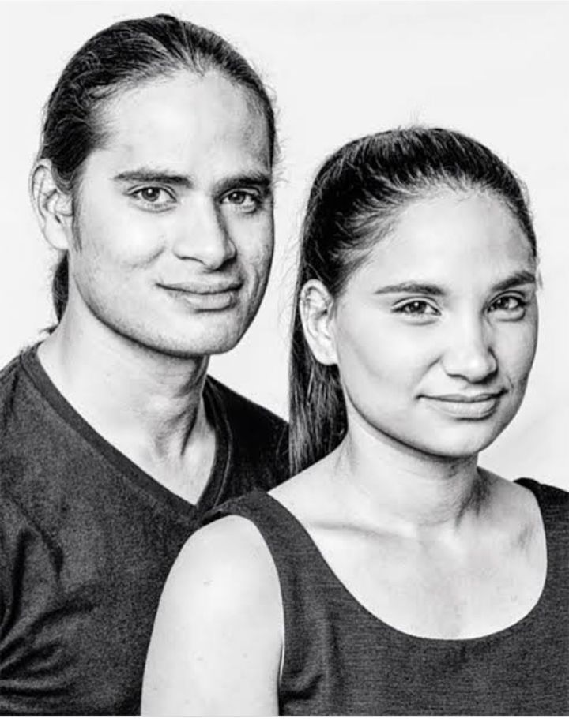

**Figure 2.31** dizygotic twins

**Features of dizygotic twins**

* They are genetically different.
* They are of the same or different sex as shown in Figure 2.31.
* They do not share the common placenta.
* They are enclosed in different membranes.
* They have different amniotic membranes.

1. **Conjoined twins**

They are also called Siamese. These result from the incomplete cleavage of the same fertilized egg (zygote) as shown in Figure 2.32.The features are the same to that of monozygotic twins except that conjoined twins share the same amniotic sac and membranes.

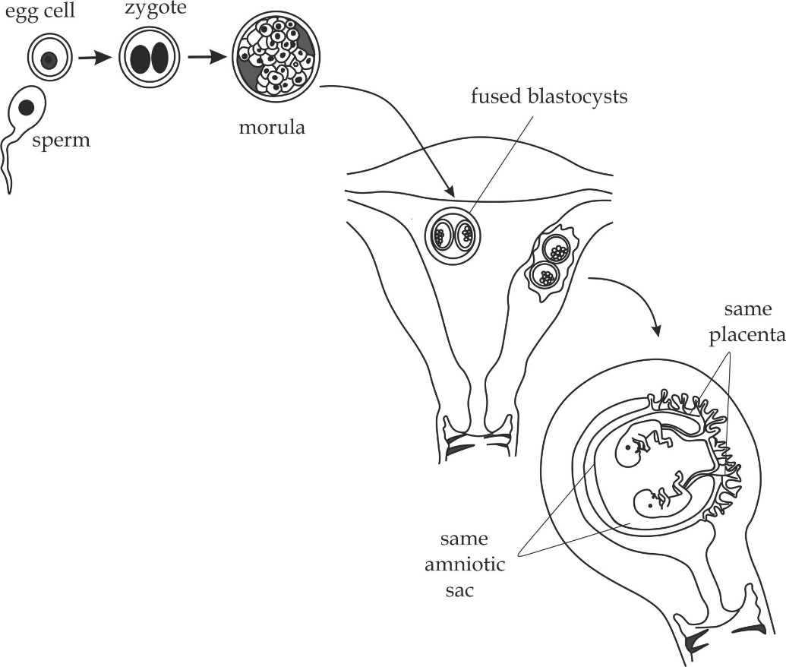

**Figure 2.32** conjoined twins

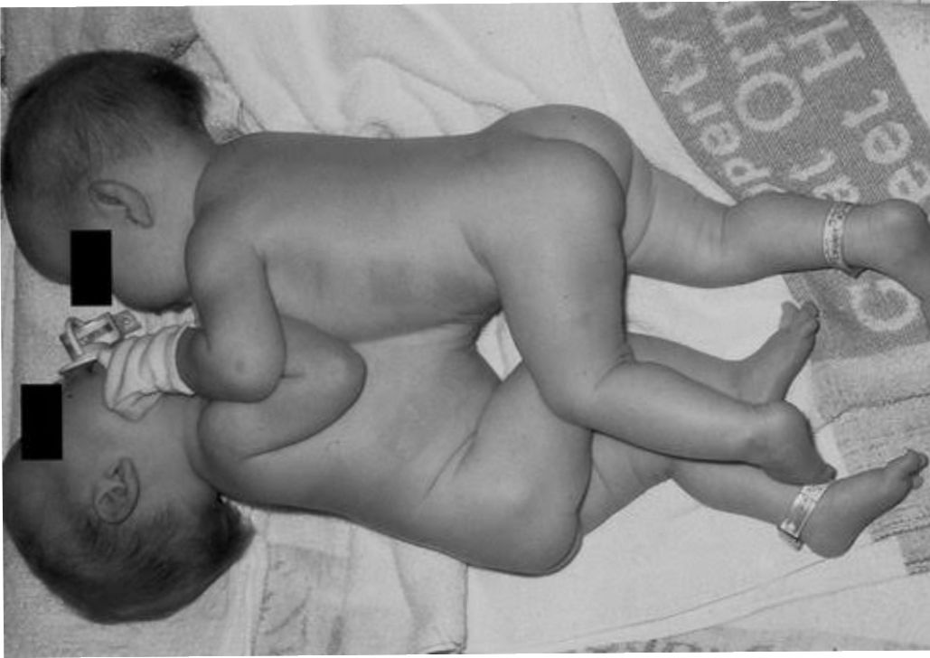

**Figure 2.33** conjoined twins at the thorax. *(Thoracopagus)*

**SAQ 2.29**

**NECTA 2014**

* Account for the birth of the following babies:

1. Identical twins
2. Fraternal twins
3. Conjoined twins

* Outline one feature for each of the births in above.